***“*DESIGN AND BUILDING**

**SMART ENERGY METER”**

**A PROJECT REPORT**

###### ***Submitted by***

**KHATRI MAYUR J 130853109015**

*Under the guidance of*

**MAYUR S. THACKER**

(Assistant professor, Department of Electrical Engineering)

*In partial fulfillment for the award of the degree*

*Of*

**BACHELOR OF ENGINEERING**

in

**ELECTRICAL ENGINEERING**

of

**DEPARTMENT OF ELECTRICAL ENGINEERING**



**HJD INSTITUTE OF TECHNICAL EDUCATION AND RESEARCH, KERA**



**GUJARAT TECHNOLOGICAL UNIVERSITY, AHMEDABAD DECEMBER, 2015**

**CERTIFICATE**

This is to certify that Project work embodied in this report entitled **“DESIGN AND BUILDING SMART ENERGY METER”** was carried out by **Khatri Mayur J.** at HJD Institute of Technical Education and Research for partial fulfilment of **Bachelor of Engineering** in ***Electrical Engineering*** to be awarded by Gujarat Technological University. This project work has been carried out under our guidance and supervision and is to the satisfaction of department.

.

Date:

Place: Kera-Kutch, Gujarat INDIA

|  |  |  |
| --- | --- | --- |
| **Signature and Name of Guide:**  **Mr. Mayur S. Thacker**  **Assistant Professor,**  **Department of Electrical Engineering** |  | **Signature and Name of**  **H.O.D**  **Mr. Pritesh R. Mankad**  **Associate Professor,**  **Department of Electrical Engineering** |

##### **Acknowledgement**

It would impossible to name each and every individual who had offered the support encouragement and idea which made this user defined project a possible thing. We are greatly thankful to our internal guide prof. **M. S. Thacker** of “*HJD Institute of Technical Education and research*, Kera – Kutch, Gujarat INDIA” who has given us a tremendous effort for shaping our idea and knowledge according to industrial requirement. He had helped us on reaching each and every milestone of the project, he had encouraged us every failure during the project, and he has increased our confidant with every success in the project. We are also thankful to our Head of the Department, Prof. **P. R. Makad** and other professors of the Electrical Department of our collage.

# Abstract

The demand for power has increased exponentially over the last century. One avenue through which today’s energy problems can be addressed is through the reduction of energy usage in households. This has increased the emphasis on the need for accurate and economic methods of power measurement.

The main object of the project is to develop smart energy meter where it is not only used to measure the consumer’s power consumption in KWH but also enable and support real consumption in rupees according to consumer tariff, so meter reader don’t need to visit each customer for the consumed data collection and to distributed the bill slip. In our developed prototype of Smart Energy meter do not have any rotating parts. The energy consumption is calculated using measurement voltage and current with help of potential divider and ACS712, measure voltage and current respectively. Power product of voltage and current, its unit watt or KW and energy is product of power (watt) and time (Hour). We have used above mentioned formulas for calculating Total Energy Consumption of consumer with Arduino Programming.

Microcontroller has an interface and we are using 16 X 2 LCD, it is used to show important unit measurements such as voltage, current, frequently, active and reactive power and power factors.

**INDEX**

|  |  |  |
| --- | --- | --- |
|  | **Title** | **Page No.** |
|  | Title page | I |
|  | Certificate | II |
|  | Acknowledgement | III |
|  | Abstract | IV |
|  | 1. Introduction and project overview | 7 |
|  | * 1. Introduction | 7 |
|  | 1.2 Overview | 7 |
|  | 1.2.1 Basic types of energy meter | 7 |
|  | 2. Literature Survey | 10 |
|  | 2.1 Paper study- 1 | 10 |
|  | 2.2 Paper study- 2 | 10 |
|  | 3. Power and Power Measurement | 11 |
|  | 3.1 Power | 11 |
|  | 3.2 Power Measurement | 13 |
|  | 3.3 Power factor | 18 |
|  | 4. Arduino Microcontroller | 19 |
|  | 5. AC Power Measurement | 21 |
|  | 5.1 Current Measurement using Arduino | 21 |
|  | 5.2 Voltage Measurement using Arduino | 24 |
|  | 5.3 Equipments | 26 |
|  | 5.4 Power Measurement using Arduino | 29 |
|  | 5.5 GSM Module Shield  5.6 Result of Measurement  6. Conclusion  6.1 Conclusion  6.2 Scope for work | 33  35  37 |
|  | 7. Reference  8. Appendix – (A) Source Code 39  9. Appendix – (B) ACS712 Current Sensor Datasheet 49 | 38 |

**TABLE OF FIGURES**

|  |  |  |
| --- | --- | --- |
| **Sr. No.** | **Figure No. & Title** | **Page No.** |
| 1. | Figure-(a) Analog Electronic Energy Meter | 8 |
| 2. | Figure-(b) Digital Electronic Energy Meter | 9 |
| 3. | Figure-(c) Power Measurement-1 | 13 |
| 4. | Figure-(d) Power Measurement-2 | 15 |
| 5. | Figure-(e) Electrodynamometer Wattmeter | 15 |
| 6. | Figure-(f) Power Triangle | 16 |
| 7. | Figure-(g) Power Measure using Multisim | 17 |
| 8. | Figure-(h) Arduino uno board | 20 |
| 9. | Figure-(i) Block Diagram of DC Power measurement | 21 |
| 10. | Figure-(j) ACS 712 Sensors | 22 |
| 11. | Figure-(k) DC regulated Power Supply | 22 |
| 12. | Figure-(l) Output Result of DC Power measurement | 23 |
| 13. | Figure-(m) Voltage measurement circuit | 24 |
| 14. | Figure-(n) Voltage circuit output waveform | 25 |
| 15. | Figure-(o) Step-down transformer | 26 |
| 16. | Figure-(p) Bridge rectifier | 27 |
| 17. | Figure-(q) Rheostat | 27 |
| 18. | Figure-(r) IC7805 | 28 |
| 19. | Figure-(s) 16×2 Display | 28 |
| 20. | Figure-(t) Load circuit | 29 |
| 21. | Figure-(u) Flow chart of power measurement | 24 |
| 22.  23.  24. | Figure-(v) High level Architecture Diagram  Figure-(w) smart energy meter hardware  Figure-(x) smart energy meter | 31  31  32 |
| 25. | Figure-(y) Result of first load | 36 |
| 26. | Figure-(z) Result of second load | 36 |

Chapter 1 Introduction and Project Overview

* 1. **Introduction**

It is an advanced metering technology involving placing intelligent meters to read, process and feedback the data to customers. It measures energy consumption, remotely switches the supply to customers and remotely controls the maximum electricity consumption. Smart metering system uses the advanced metering infrastructure system technology for better performance.

These are capable of communicating in both directions. They can transmit the data to the utilities like energy consumption, parameter values, alarms, etc and also can receive information from utilities such as automatic meter reading system, reconnect/disconnect instructions, upgrading of meter software’s and other important messages. These meters reduce the need to visit while taking or reading monthly bill. Modems are used in these smart meters to facilitate communication systems such as telephone, wireless, fiber cable, power line communications. Another advantage of smart metering is complete avoidance of tampering of energy meter where there is scope of using power in an illegal way.

* 1. **Overview-**

In this project designing and building smart energy meter, the aim is to provide awareness to consumer that power consumption and load circuit is measured using Arduino Programming sketch. The load circuit is consist of resistive, inductive and capacitive or combination of above. The current flowing circuit is used to measure the suitable technique and its signal given to Arduino board. Power is being measured using Arduino programming sketch and it is also used to measure other quantities such as power factor, active and reactive power etc. and everything is displayed to LCD.

Power of DC circuit and purely resistive AC circuit power is product of voltage and current and reactive AC current is called as apparent power(VA).

Arduino is an open source single board microcontroller and it provided as open source, writing platform design to make the process of using electronics in multidisciplinary project. Arduino is flexible and easy understanding hardware cum software in our project we have used Arduino Uno microcontroller based on the Atmega 328.

**1.2.1 Basic types of Energy meters**

**1.2.1.1 Electromechanical induction type Energy meter**

It is the popularly known and most common type of age old watt hour meter. It consists of rotating aluminum disc mounted on a spindle between two electro magnets. Speed of rotation of disc is proportional to the power and this power is integrated by the use of counter mechanism and gear trains. It comprises of two silicon steel laminated electromagnets i.e., series and shunt magnets.

**1.2.1.2 Electronic Energy meters**

These are of accurate, high procession and reliable types of measuring instruments as compared to conventional mechanical meters. It consumes less power and starts measuring instantaneously when connected to load. These meters might be analog or digital. In analog meters, power is converted to proportional frequency or pulse rate and it is integrated by counters placed inside it. In digital electric meter power is directly measured by high end processor. The power is integrated by logic circuits to get the energy and also for testing and calibration purpose. It is then converted to frequency or pulse rate.

**-** **Analog Electronic Energy Meters**

In analog type meters, voltage and current values of each phase are obtained by voltage divider and current transformers respectively which are directly connected to the load as shown in figure.

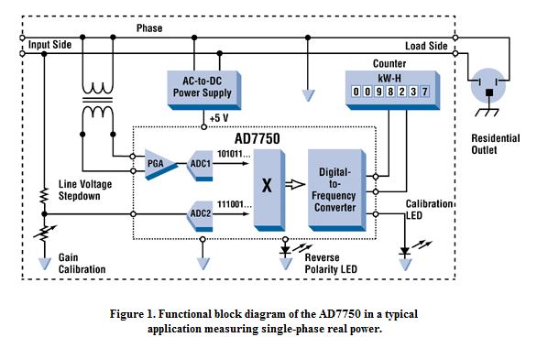

Figure-(a) Analog Electronic Energy Meter

Analog to digital converter converts these analog values to digitized samples and it is then converted to corresponding frequency signals by frequency converter. These frequency pulses then drive a counter mechanism where these samples are integrated over a time to produce the electricity consumption.

**-** **Digital Electronic Energy Meters**

Digital signal processor or high performance microprocessors are used in digital electric meters. Similar to the analog meters, voltage and current transducers are connected to a high resolution ADC. Once it converts analog signals to digital samples, voltage and current samples are multiplied and integrated by digital circuits to measure the energy consumed.

[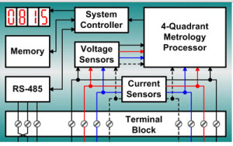](http://www.edgefx.in/wp-content/uploads/2014/02/5.jpg)

Figure-(b) Digital Electronic Energy Meter

Microprocessor also calculates phase angle between voltage and current, so that it also measures and indicates reactive power. It is programmed in such a way that it calculates energy according to the tariff and other parameters like power factor, maximum demand, etc and stores all these values in a non volatile memory EEPROM.

It contains real time clock (RTC) for calculating time for power integration, maximum demand calculations and also date and time stamps for particular parameters. Furthermore it interacts with liquid crystal display (LCD), communication devices and other meter outputs. Battery is provided for RTC and other significant peripherals for backup power.

Chapter 2 Literature Survey

**2.1 Paper study- 1**

* Measurement of power and energy using Arduino.
* Research journal of engineering sciences ISSN 2278-9472 srvidyadevi P. pushalathe D. V. and Sharma P. M.
* This paper demonstrates the measurement of power and energy using Arduino microcontroller. Now a day, the usage of energy is increased as compare to past and accurate energy measurement techniques is enquired. The goal of providing such a data is to optimize and reduce thousands of power consumption.
* In this paper demonstrates the power measure with the help of Arduino Uno microcontroller, offset voltage transformer and load, the function of offset data conditioning and it is used to clamp the given AC signal with respect to a reference DC voltage and current transformer and voltage transformer used for step down voltage and current to single phase AC supply to apply signal DC offset.
* Over here, Arduino Uno is a brain of the project and it is open source microcontroller by sensor current and voltage with the help of offset current and voltage conditioning cord, and with help of Arduino programmed used to measure the power in circuit with different load (single load, two loads, three loads) used to display at serial monitor and plot the graph.

**2.1 Paper study- 2**

* An automated energy metering system Home based approach.
* Aswatht D. R. ,C. shabthi
* International journal of advance research in electrical, electronics and instruments engineering.
* Smart meter are the key component of the smart grid which helps both the user and supplier to control resource.
* In this paper energy is consist of voltage and current controlling platform unit, level shifter and Arduino in single phase AC line voltage and current sensor with help of step down transformer and level shifter , output is DC is proportional to AC system it is applied on Arduino for measuring the power.
* In this paper Communication is being done using Arduino Ethernet board that used to store transmitted data in the web page with the lowest cost and it sends consumption data to their remote server and it is also achieved the controlling and managing energy consumption of electricity usage of the consumer.

Chapter 3 Power and Power Measurement

**3.1 Power-**

Power means rate of expanding energy. The unit of power is watt (joule per second j/s ). In DC circuit and purely resistive AC circuit power is product of voltage and current. For reactive AC circuit the product of r.m.s values voltage and r.m.s value of current is called apparent power (VA).

The potential difference in volts between two points is equal to the energy per unit charge (in joules/coulomb) which is required to move electric charge between the points since the electric current measure the charge per unit time (in coulomb/second). The electric power P is given by the product of the current I and the voltage V (in joule/sec = watts).



Where,

Q=electric charge in coulombs

t=time in sec.

I=electrical current in ampere

V=electrical potential or voltage in volts

* + 1. **DC Circuit Power-**

In a dc circuit if VL is the voltage supped to load and IL is the load current ten the dc load power is given by the product of the load supply voltage VL and the load current IL thus,

Pdc = VL IL watt

If RL is the resistance of the load than,



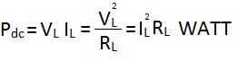

* + 1. **AC Circuit Power-**

In alternating current circuit due to energy storage element such as inductance and capacitance may result in periodic reversals of the direction of energy flow.

Thus,





Than the average power given by,

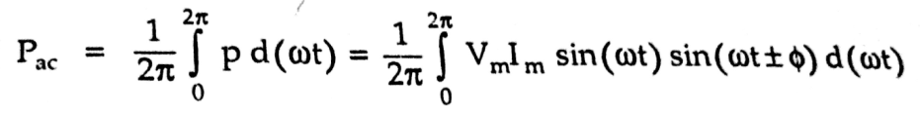

This gives the average power consumption in a.c. circuit as,

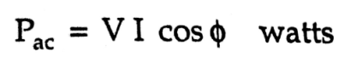

Where,

V = r.m.s. value of the voltage=Vm/2

I = r.m.s. value of the current=Im/2

Cosφ = power factor of circuit

Φ = power factor angle=V^I

* + 1. **Active Power**–

The production of power flow that avarage over a complate cycle of the ac waveform result is net transfor of energy is one cycle is known as real power (active power ) it is power consumed by the resistive element in the circuit active power is the power that is actualy being consume by the load.

* + 1. **Reactive Power–**

The portion of the power flow due to storage element that return to the source in each cycle is known as reactive power When the voltage and current are perodic with same functional frequency. the instantaneous power is also perodic with twice the functional frequency.

**3.1.5 Avarage Power-**

Average power is defined as energy transfer rate average over many peroid of the lowest frequncy in signal. It is also defined as average amount of workdone or energy converted per unit of time, if is the amount of work performed during a period of time

The average power Pavg over the period is given by the formula

Pavg=

* + 1. **Instantaneous Power-**

The instantaneous power is than the limiting value of average power as the time interval approaches zero.

P=Limit avg

Electric power is generally developed by electric generator but can also be supplied by chemical source such as electric battery. Electric power generally supplied to businesses and home by the electric power energy.

**3.2 Power Measurement-**

We measure power is both type of circuit AC as well as DC.

Power is measured by following techniques.

1. Using measuring device and
2. Using software by interfacing the circuits

**3.2.1 Power measurement using various measuring equipment-**

Power is product of voltage and current so we measure voltage and current for measurement of power.

* + - 1. **Using voltmeter and ammeter-**

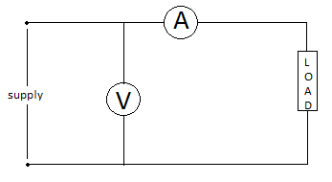

Figure-(c) Power Measurement-1

Consider the circuit using voltage and ammeter for the measurement of power, as shown in fig.(c).

The ammeter measures the load current Il and there is voltage drop Va=IlRa across the ammeter where Ra is the ammeter resistance.

* VL = V - Va
* ­PDC = VLIL = (V – VA)IL
* Pdc = VIL – VAIL

Where,

VIL = Power measured by the meters

Pdc = Power consumed by load.

VA IL = Power consumed by ammeter.

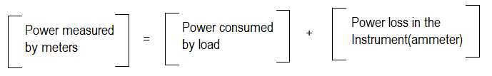

Hence the product of ammeter and voltmeter does not give correct power consumed by the load.

If the voltmeter is shifted across the load to measure the load voltage, the circuit becomes as shown in the Fig.

Now as voltmeter is across the load, it measure VL correctly but ammeter measures current I which is sum of IL and IV.

I = IL + IV

* Pdc = VL IL = VL (I – IV ) = IVL  - VLIV

Where,

IVL = Power measured by meters

Pdc = Power consumed by load

VLIV = Power consumed by voltmeter

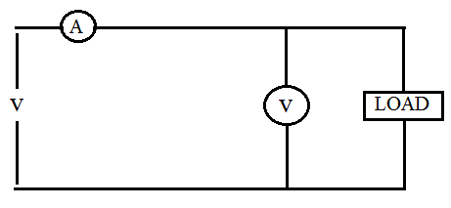

Figure-(d) Power Measurement-2

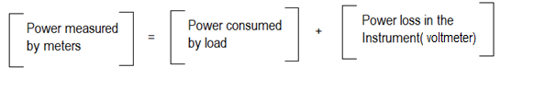

This by any method, the power measured is higher than the power actually consumed by the load. The power loss in the instrument near the load causes the error.

**3.2.2** **Using wattmeter**

**3.2.2.1 Dynamometer –**

A dynamometer can measure power in both DC and AC systems. A dynamometer has two coils: static coil and movable coil. It uses the interaction between the magnetic fields produced by the currents in two coils or sets of coils to measure power. Torque is proportional product of current in current coil and current in voltage coil. The Accuracy of dynamometer is nearly 0.25 %.

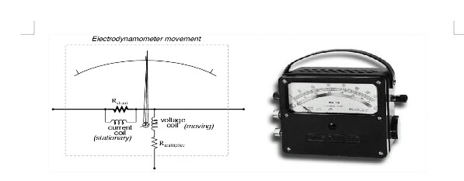

Figure-(e) Electrodynamometer Wattmeter

**3.2.2.2 Digital wattmeter (up to 100 kHz)–**

A modern digital electronic wattmeter/energy meter samples the voltage and current thousands of times a second. For each sample, the voltage is multiplied by the current at the same instant; the average over at least one cycle is the real power. A computer circuit uses the sampled values to calculate RMS voltage, RMS current, VA, power (watts), power factor, and kilowatt-hours. The readings may be displayed on the device, retained to provide a log and calculate averages, or transmitted to other equipment for further use.

**Advantages of digital wattmeter-**

* High Resolution
* High Accuracy
  + - 1. **Power Triangle Method –**

Real and reactive powers can also be calculated directly from the apparent power, when the current and voltage are both sinusoids with a known phase angle θ between them:

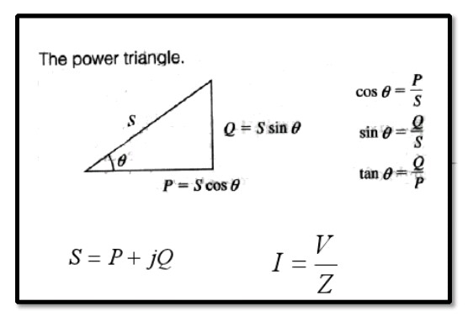

Figure-(f) Power Triangle

(Apparent power)2 = (real power)2+ (Reactive power)2

Real power = (apparent power)*(cosØ)

Reactive power = (apparent power)*(sinØ)

1. **Power measurement using software-**
2. **Power measurement using Multisim:**

In Multisim power can be measured using various methods like 1-wattmeter method, 2-wattmeter method, 3-wattmeter method. One such method is discussed in detail here.

Two wattmeter method: In this method power is measured for three phase balanced loads using two wattmeter. The total power consumed is calculated using the below formula.

Total Power Consumed, Wtotal= √3*(W1+ W2)

Where,

W1 – first wattmeter reading

W2 – second wattmeter reading

Let us consider a three phase circuit having resistive balanced loads. Connect the circuit in multisim and the total power calculated is 900watts using the above formula. Simulation circuit of 2-wattmeter method power measurement in multisim.

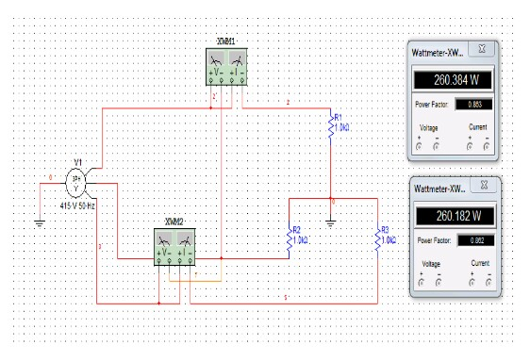

Figure-(g) Power Measure using Multisim

1. **Power measurement using Labview:**

Power measurement can also be done using Labview software. Labview is a system design platform and development environment for a visual programming language. Labview ties the creation of user interfaces (called front panels) into the development cycle. Labview programs/subroutines are called virtual instruments (VIs). The graphical approach also allows non-programmers to build programs by dragging and dropping virtual representations of lab equipment with which they are already familiar.

For a three-phase system, a single-phase wattmeter can be connected in each phase. Using this three-wattmeter configuration, the total real power can be obtained by adding the three wattmeter readings.

Total power consumed, P = P1 + P2+ P3

Where,

P1- wattmeter reading first phase

P2- wattmeter reading second phase

P3- wattmeter reading third phase

* 1. **Power factor -**

The ratio between real power and apparent power in a circuit is a called the power factor it is a practical measure of the efficiency of a power distribution system.

For example if two system transmitting transfer equal amount of real power, if one transmitting system have lower power factor so higher circulating current due to energy to the source from energy storage in the load due to higher current its produced higher losses and efficiency of transmission line is decrease and a lower power factor circuit subjected to higher apparent power and higher losses for equal or same value of real power.

When voltage and current waveform are in a phase than power factor is unity and when current leads or lags to the voltage by 90 degree when power factor is zero. Basically power factor state as ‘leading’ or ‘lagging’ to show the sign of phase angle of current with respect to voltage.

In purely capacitive circuit supply is reactive power so current lead the voltage by 90 degree which purely inductive circuits property of inductance is absorb reactive power so current waveform lagging to the voltage waveform by 90 degree.

That means if capacitor and inductance connected in single circuit that cancel out effect of each other.

When the system waveform is purely sinusoidal the power factor is the cosine of the phase angle between the I V sinusoidal waveform.

Chapter 4 Arduino Microcontroller

Arduino is open source microcontroller and software development environment and easy to use and understand hardware and software. Arduino is a single board microcontroller has programming language is a simple ‘C’ and ‘C++’ type programming language and C language is easy to learn.

Arduino microcontroller is fast made by “Interaction Design Institute Ivrea” in Ivera, Italy; it has aim was design low cost and cheap microcontroller board. Arduino uses expansion circuit board knows as shield. It has facility to GPD, GDM, and Bluetooth, zigbee, motor and other facility.

This organization has developed 50,000 Arduino microcontroller boards in very short period. In 2011 Google announced the Arduino open accessories development kit, which enable Arduino board to interfaced with Arduino mobile platform.

In a market different Arduino board available for different requirement. They Arduino board are used for ATMGT microcontroller.

The types of Arduino board are,

* Arduino Uno board,
* Arduino mega board and
* Arduino lily pad Arduino board.

In our project we have used Arduino Uno board has a digital input / output pins, six analog inputs, 6 PWM pins and 16Mhz ceramic resonator a power jack on OICSP heady and a reset button it has on board one USB to serial convert and connect to computer using USB cable.

**Features of Arduino Uno board-**

* It is based on AI mega 328 microcontroller
* Input voltage range is 7.12V.
* Digital I/O pins is 14 (of which 6 pin provide PWM output)
* 6 analog input pins.
* 32KB flash memory 0.5KB used by boot leader.
* 16MHz clock speed.
* DC current for I/O pin 40mA.

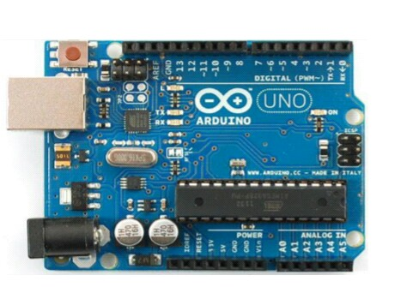

Figure-(h) Arduino Uno board

**Pins of Arduino Uno microcontroller-**

* **Reset pin-** This pin enable to reset Arduino microcontroller board.
* **IOEF-** This pin act as a reference to the input given to the Arduino board.
* Arduino has 6 analog pins A0 to A5.
* There are 14 digital pins from 0-13 among these (3,5,9,1,11) are PMW pins from which analog output taken from the Arduino board.
* There is inbuilt LED on Pin 13.
* **AREF**- This pin is acting as a reference to analog input.
* **RXTX** – used for receiving and transmitting serial data.
* **ICSP** (In circuit serial programming) - this pin enable the use to programmed the chips on the circuit.

Chapter 5 AC Power Measurement using Arduino

**5.1 Current Measurement using Arduino –**

**5.1.1. Block Diagram-**

The block diagram of the DC power measurement Arduino as shown in circuit load are used rheostat rating is 300 ohm, 1.2A. The load get supply from DC power supply unit (20V). Current through load has sense using acs712 current sensor and we multiply voltage directly to current using program

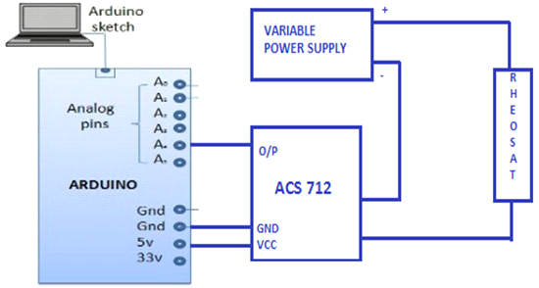

Figure-(I) Block Diagram of DC Power measurement

* **ACS 712-**

ACS712 current sensor is based on the principle of Hall-effect, which was discovered by Dr. Edwin Hall in 1879. According to this principle, when a current carrying conductor is placed into a magnetic field, a voltage is generated across its edges perpendicular to the directions of both the current and the magnetic field.

ACS712 device is provided in a small, surface mount SOIC8 package. It consists of a precise, low-offset, linear Hall sensor circuit with a copper conduction path located near the surface of the die. When current is applied through the copper conductor, a magnetic field is generated which is sensed by the built-in Hall element. The strength of the magnetic field is proportional to the magnitude of the current through the conduction path, providing a linear relationship between the output Hall voltage and input conduction current.

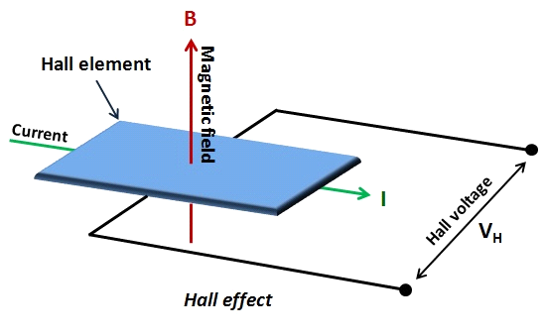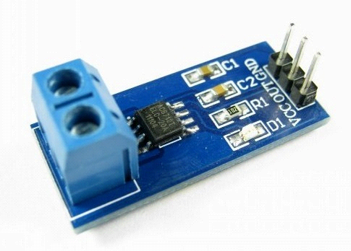

Figure-(j) ACS 712 Sensors

.

The ACS712 device comes in three variants, providing current range of±5A (ACS712-05B), ±20A (ACS712-20B), and ±30A (ACS712-30A). The ACS712-05B can measure current up to ±5A and provides output sensitivity of 185mV/A (at +5V power supply), which means for every 1A increase in the current through the conduction terminals in positive direction, the output voltage also rises by 185 mV. The sensitivities of 20A and 30A versions are 100 mV/A and 66 mV/A, respectively

* **Variable Power supply-**

The variable power supply consist of an AC input circuit and transformer, a bias supply consisting of an rectifier, filter, pre-regulated and reference voltage source, a main regulating circuit consisting of the main rectifier and filter, a series regulator, a current comparator, voltage comparator, reference voltage amplifier and relay control circuit.

Single phase power is applied to transformer through the input circuit and auxiliary rectifier provides bias voltage is filtered by capacitor that provides a regulated voltage for element of active. The main rectifier, a full wave bridge rectifier, provides the power which is filtered by capacitor and derivers to the output.

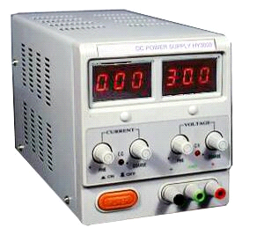

Figure-(k) DC regulated Power Supply

* **Output Result of DC Power measurement-**
* 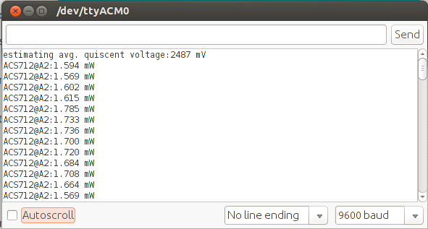

Figure-(l) Output Result of DC Power measurement

|  |  |  |  |  |
| --- | --- | --- | --- | --- |
| **Sr. NO,** | **Voltage (V)** | **Current(mA)** | **Power(mW)** | **Resistance (ohm)** |
| **1** | **20** | **0.08075** | **1.615** | **247** |
| **2** | **20** | **0.075** | **1.5** | **265** |
| **3** | **20** | **0.072** | **1.4546** | **275** |
| **4** | **20** | **0.067** | **1.34** | **300** |

Table-1 Output Result of DC Power measurement

**5.2 Voltage Measurement using Arduino –**

**5.2.1 Voltage sensor**

Voltage is a force that makes to move electricity through wire Voltage is electric potential energy per unit charge measured by joules per coulomb. It has unit as *volt*. It’s also used to define the potential difference between two points. Voltage is always measured between two points, for example between the positive and negative ends of battery, or between a wire and ground.

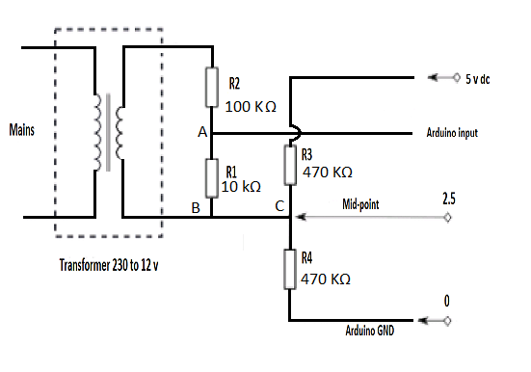

Figure-(m) Voltage measurement circuit

AC Voltage continually alternates it’s behavior as the name suggests, we cannot directly interface Arduino to single phase ac system in this place some voltage isolation is required. See, the above fig for voltage measurement using Arduino. It is consists a step down voltage transformer (230 v to 12v) voltage divider and dc offset for eliminating negative portion of voltage.

**5.2.1.1 Working:**

The voltage measurement using Arduino the input voltage is must in range 0 to 5v. It’s achieved using above circuit. AC voltage is step down with help of voltage transformer, its primary winding is connected across the supply and its secondary winding is connected to voltage divider circuit for reduced further voltage level.

**5.2.1.2 Output waveform of Voltage Circuit -**

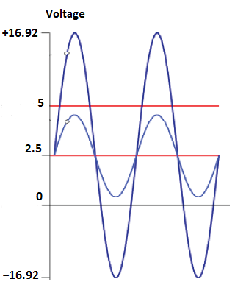

Figure-(n) Voltage circuit output waveform

The output of voltage divider circuit is so small around 1.5 to 2v.for eliminating the negative portion of signal we have added the DC voltage offset so resultant output of voltage circuit is violet between 0 to 5v corresponding 230v ac voltages.

**5.3 Equipments –**

**5.3.1. Transformer –**

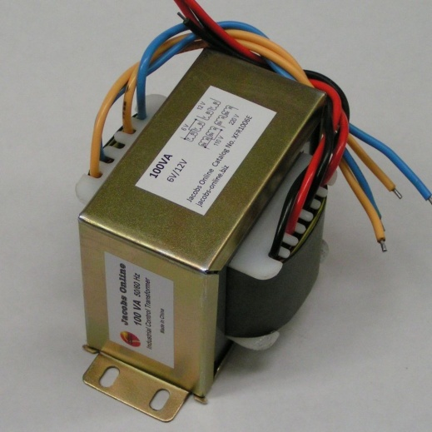

Figure-(o) Step-down transformer

The step-down converters are used for converting the high voltage into low voltage. The converter with output voltage less than the input voltage is called as a step-down converter, and the converter with output voltage greater than the input voltage is called as step-up converter. There are step-up and step-down transformers which are used to step up or step down the voltage levels. 230V AC is converted into 12V AC using a step-down transformer. 12V output of step-down transformer is an RMS value and its peak value is given by the product of square root of two with RMS value, which is approximately 17V.

**5.3.2. Rectifier –**

Bridge rectifier consists of four diodes which are connected in the form a bridge. We know that the diode is an uncontrolled rectifier which will conduct only forward bias and will not conduct during the reverse bias. If the diode anode voltage is greater than the cathode voltage then the diode is said to be in forward bias.

During positive half cycle, diodes D2 and D4 will conduct and during negative half cycle diodes D1 and D3 will conduct. Thus, AC is converted into DC; here they obtained is not a pure DC as it consists of pulses. Hence, it is called as pulsating DC power. But voltage drop across the diodes is (2*0.7V) 1.4V; therefore, the peak voltage at the output of this rectifier circuit is 15V (17-1.4) approx.

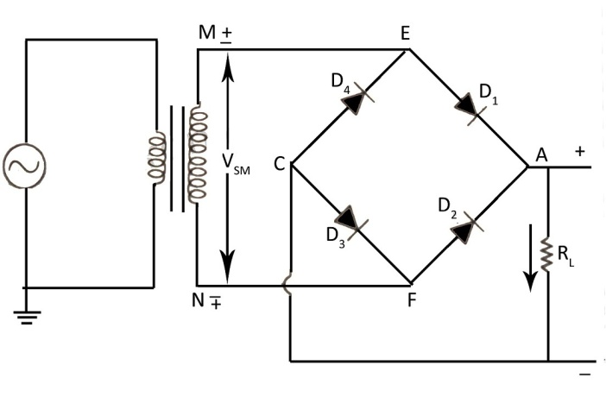

Figure-(p) Bridge rectifier

**5.3.3. Rheostat –**

It is a variable resistance usually consistence of a coil of a wire have two terminal one is fixed and other is sliding contact that move along the coil to tap of the current rheostat adjustable resistors so connected that it is resistance to be changed without opening electrical circuit in which it is connected there by controlling the current in the circuit.

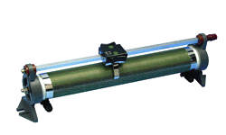

Figure-(q) Rheostat

**5.3.4. IC7805 –**

Voltage regulator IC's are the IC’s that are used to regulate voltage. IC 7805 is a 5V Voltage Regulator that restricts the voltage output to 5V and draws 5V regulated power supply. It comes with provision to add heat sink.

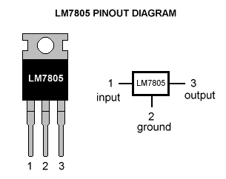

Figure-(r) IC7805

The maximum value for input to the voltage regulator is 35V. It can provide a constant steady voltage flow of 5V for higher voltage input till the threshold limit of 35V. If the voltage is near to 7.5V then it does not produce any heat and hence no need for heat sink. If the voltage input is more, then excess electricity is liberated as heat from 7805.

**5.3.5. Display –**

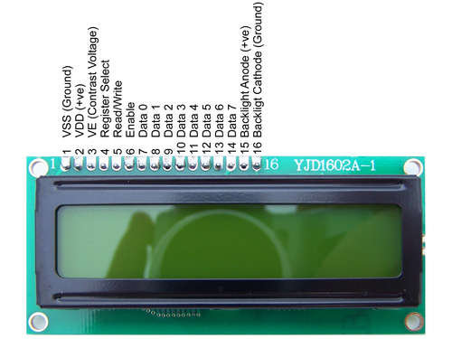

Figure-(s) 16×2 Display

LCD (Liquid Crystal Display) screen is an electronic display module and find a wide range of applications. A 16x2 LCD display is very basic module and is very commonly used in various devices and circuits. These modules are preferred over [seven segments](http://www.engineersgarage.com/content/seven-segment-display) and other multi segment [LED](http://www.engineersgarage.com/content/led)s. A **16x2 LCD** means it can display 16 characters per line and there are 2 such lines. In this LCD each character is displayed in 5x7 pixel matrix.

**5.4 Power Measurement using Arduino –**

The power is an A.C. circuit is given by the relation,

P = V*I*cos Ø

Such that cos Ø power factor of circuit .purely inductive and capacitive circuits do not consume any power because load waveform of such type of circuits are voltage and current are out of phase means the phase difference between them equal to zero cos 90=0 so power in load is P=V*I*0=0

Whereas resistive load the waveform of voltage and current are in phase means the phase difference between them equal to zero cos 0=1 so power in resistive load is P=V*I only.

**5.4.1 Load circuit:**

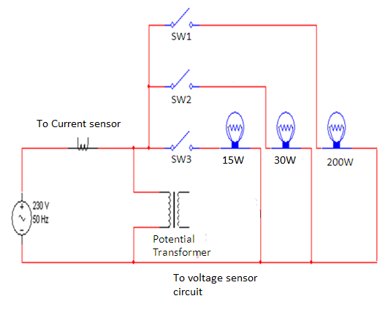

Figure-(t) Load circuit

The load circuit consists of resistive loads which are bulbs as shown in the figure. These loads are each of wattage 15watts, 30 watts and 200watts. The maximum load being used is 245watts.The current and voltage values of load are stepped down by using current sensor and potential transformer respectively.

**5.4.2 Flow chart of power measurement-**

Figure-(u) Flow Chart

**5.4.3 High level Architecture diagram**

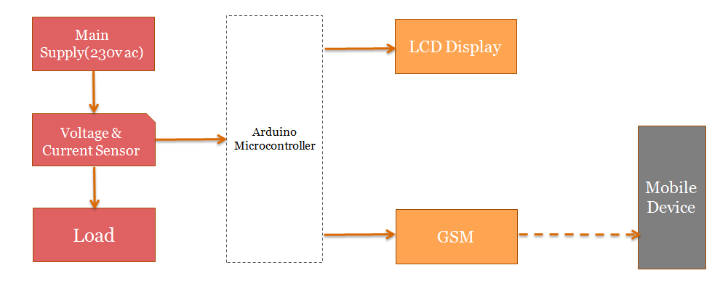 Figure-(v) High level architecture diagram Figure

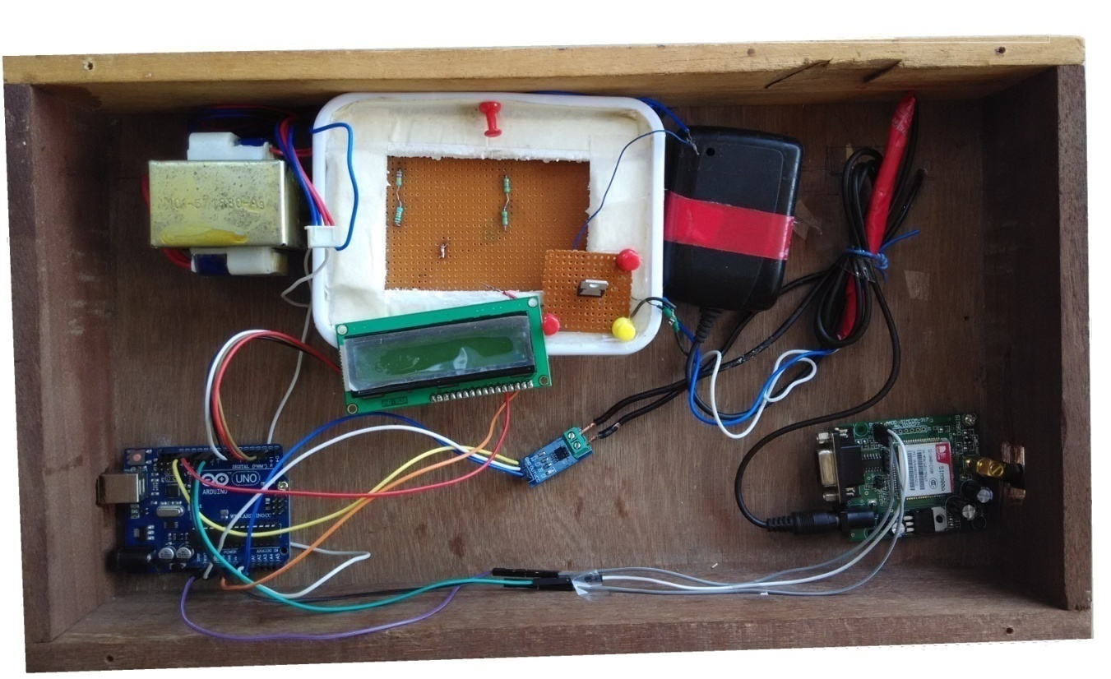

Figure-(w) smart energy meter hardware

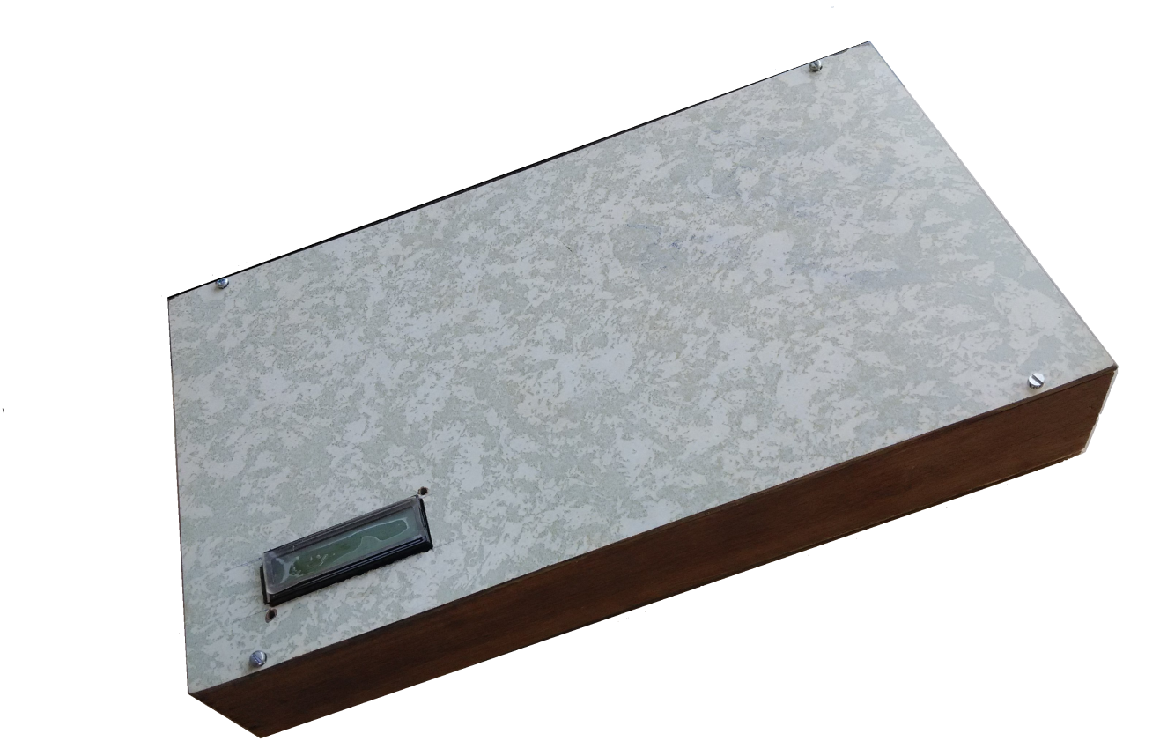

Figure-(x) smart energy meter

* 1. **GSM Module Shield –**

The Arduino GSM Shield connects your Arduino to the internet using the GPRS wireless network. Just plug this module onto your Arduino board, plug in a SIM card from an operator offering GPRS coverage and follow a few simple instructions to start controlling your world through the internet. You can also make/receive voice calls (you will need an external speaker and microphone circuit) and send/receive SMS messages.

The Arduino GSM Shield allows an Arduino board to connect to the internet, make/receive voice calls and send/receive SMS messages. The shield uses a radio modem M10 by Quectel. It is possible to communicate with the board using AT commands. The GSM library has a large number of methods for communication with the shield.

We have used SIM900 model of GSM Module shield, The Arduino GSM Shield allows an Arduino board to connect to the internet, make/receive voice calls and send/receive SMS messages. The shield uses a radio modem M10 by Quectel. It is possible to communicate with the board using AT commands. The GSM library has a large number of methods for communication with the shield.

GPRS module is a breakout board and minimum system of SIM900 Quad-band/SIM900A Dual-band GSM/GPRS module. It can communicate with controllers via AT commands (GSM 07.07 ,07.05 and SIMCOM enhanced AT Commands). This module supports software power on and reset.

**Features:**

* Quad-Band 850/ 900/ 1800/ 1900 MHz
* Dual-Band 900/ 1900 MHz
* GPRS multi-slot class 10/8GPRS mobile station class B
* Compliant to GSM phase 2/2+Class 4 (2 W @850/ 900 MHz)
* Class 1 (1 W @ 1800/1900MHz)
* Control via AT commands (GSM 07.07 ,07.05 and SIMCOM enhanced AT Commands)
* Low power consumption: 1.5mA(sleep mode)
* Operation temperature: -40°C to +85 °C

**Specification:**

|  |  |
| --- | --- |
| PCB size | 71.4mm X 66.0mm X1.6mm |
| Indicators | PWR, status LED, net LED |
| Power supply | 12V |
| Communication Protocol | UART |
| RoHS | Yes |

**Electrical Characteristics:**

|  |  |  |  |  |
| --- | --- | --- | --- | --- |
| **Parameter** | **Min.** | **Typical** | **Max.** | **Unit** |
| Power voltage (Vsupply) | 4.5 |  | 5.5 | VDC |
| Input voltage VH | 0.7VCC |  | 5.5 | V |
| Input voltage VL | -0.3 | 0 | 0.3VCC | V |
| Current Consumption (pulse) | - |  | 2000 | mA |
| Current Consumption (continues) |  |  | 500 | mA |
| Baud Rate |  | 115200 |  | Bps |

|  |  |  |
| --- | --- | --- |
| **Interface** | **Pin** | **Description** |
| Rst | 1 | Reset the SIM900 module |
| P | 2 | Power switch pin of SIM900 module |
| Tx | 3 | UART data output |
| Rx | 4 | UART data in |
| DT | 5 | Debug UART data output |
| DR | 6 | Debug UART data input |
| - | 7 | GND |
| + | 8 | VCC |

***Installation***

**Power on GPRS module**

User can power on the GPRS module by pulling down the PWR button or the P pin of control interface for at least 1 second and release. This pin is already pulled up to 3V in the module internal, so external pull up is not necessary. When power on procedure is completed, GPRS module will send following URC to indicate that the module is ready to operate at fixed baud rate.

**Indicator LED and Buttons:**

NETSTATUS: The status of the NETSTATUS LED is listed in following table:

|  |  |
| --- | --- |
| **Status** | **Description** |
| Off | SIM900 is not running 64ms On/800ms |
| Off | SIM900 not registered the network |
| 64ms On/3000ms Off | SIM900 registered to the network |
| 64ms On/300ms Off | GPRS communication is established |

**STATUS:** Power status of SIM900.

**PWR:** Power status of GPRS module.

**PWR:** After the GPRS module power on, you need to press the POWER button for a moment to power on the SIM900 module.

**RESET:** Reset the SIM900 module.

* 1. **RESULT MEASUREMENT -**

1. **First load-**

When the first load having a rating of 30 watts is switched on, the Arduino Serial monitor displays the RMS voltage 256 volts, RMS current 0.39 amps and average power consumed as 30watts in its COM window as shown in figure.

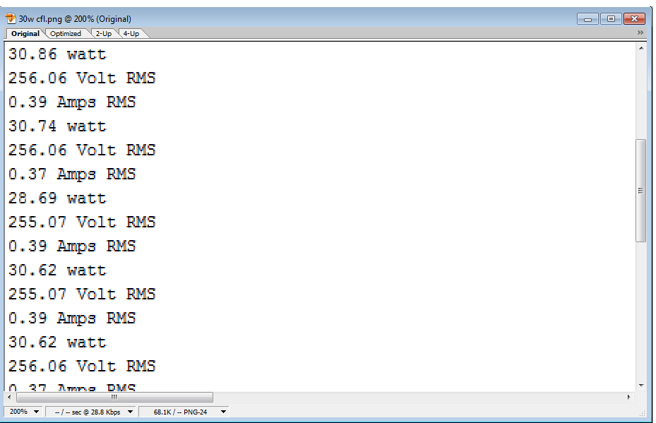

Figure-(y) Result of First load

1. **Second load-**

When the second load having a rating of 30 watts is switched on, the Arduino Serial monitor Displays the RMS voltage 256 volts, RMS current 0.18 amps and average power consumed as 15 watts in its COM window as shown in figure.

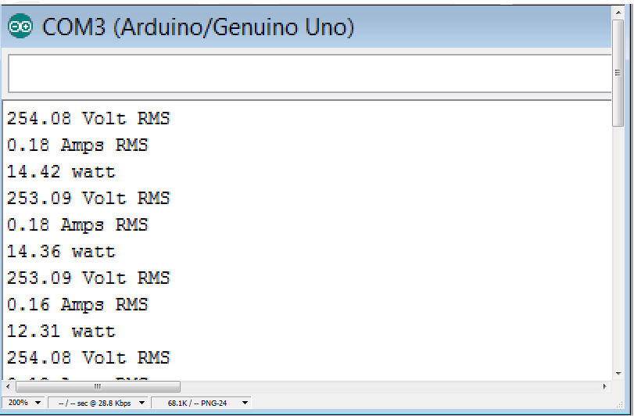

Figure-(z) Result of second load

Chapter 6 CONCLUSIONS

### Conclusion

Power measurement is done for resistive loads using Arduino environment. Results for the various loads are shown in simulation. Arduino Power Measurement is an advanced method of determining power and this method is more advantageous than other software’s such as matlab. The advantages of Arduino over other software’s are it simplifies the amount of hardware and software development required in order to get a system running. In this also measure the energy consumption in real value and also store its display with help of 16*2 LCD display. It is open source software and can be extended by experienced programmers. Arduino has simple and clear programming environment and also has a quicker writing code.

### Scope for work

Proper performance, reliability, stability of power being consumed and generated must be ensured. Therefore it is necessary to measure, test and analyze the power consumption to every aspect of power system for its performance and behavior, under normal as well as extreme operating conditions.

The present project can be further extended for measuring the load power factor. This reading can be interfaced to the web page for easy understanding. The same can be displayed graphically like this in Arduino add TV library and energy consumption plot graph in TV to observe the excess consumption of energy and can be minimized accordingly.

Apart from this Arduino based three phase energy meter can also be implemented. The Arduino based three phase energy meter is large rating compare to household meter. This method provides the domestic power consumption accurately, safely, and with a relatively fast update rate, thus helping the user optimize and reduce their power usage.

**Reference:**

**[1]** An Automated Energy Metering System - Home Based Approach Aswathy P.R1,

C.Shanthi2

**[2]** A COGNITIVE ENERGY DISTRIBUTION SYSTEM SANUKRISHNAN S.B.

**[3]** A Novel Approach for Automatic Monitoring of Power Consumption using Smart

Meter P. Saraswathi1, M. Prabha2

**[4]** YoMo - The Arduino-based Smart Metering Board Christoph Klemenjak, Dominik

Egarter, and Wilfried Elmenreich Institute of Networked and Embedded

SystemsAlpen- Adria-Universit¨atKlagenfurt,Austria {name.surname}@aau.at

**[5]** Development of a prototype for remote current measurements of PV panel using WSN

S. Zahurula*, N. Mariuna , V. Grozescub , M. Lutfia , H. Hashima, M. Amrana,

Izhamc

**[6]** Design and Building of a Cheap Smart Meter Arne Ellerbrock, Student Member,

IEEE, Ahmad Abdel-Majeed

**[7]** Energy and Water Monitoring System for Smart Metering and Consumer Awareness

Shiu Kumar

**[8]** Programming in ANSI C Balagurusamy Tata McGraw-Hill Education, 2008

**[9]** MOOC - Coursera - The Arduino Platform and C Programming by Prof. Ian Harris

Associate Professor, The University of California, Irvine

**[10]** MOOC - Coursera - Interfacing with the Arduino by by Prof. Ian Harris Associate

Professor, The University of California, Irvine

**[11]** Getting Started with Arduino, 2nd Edition By Massimo Banzi

**[12]** Arduino Cookbook 2nd Edition by Michael Margolis

**[13]** ARDUINO WITH GSM - Making a Call & Sending SMS

Ref. https://youtu.be/WAvZ3SSQR74

**[14]** Arduino connected to an Android phone via Bluetooth (JY-MCU module) Ref.

https://youtu.be/K1S6G4_eCZM

**[15]** Arduino Tutorial Series by Jeremy Blum

***Ref.*** https://youtu.be/fCxzA9_kg6s?list=PLA567CE235D39FA84

**[16]** Measurement of Power and Energy Using Arduino - ISCA

***Ref***. www.isca.in/IJES/Archive/v2/i10/2.ISCA-RJEngS-2013-115.pdf

***Source***: Oct 24, 2013 - Research Journal of Engineering Sciences. ISSN 2278 –

9472. Vol. 2(10) ... Srividyadevi P., Pusphalatha D.V. and Sharma P.M.. Gokaraju

**[17]** An automated energy metering system Home based approach.

Aswatht D. R. ,C. shabthi , International journal of advance research in electrical, electronics and instruments engineering.

***Ref.*** www.ijets.in/Downloads/Published/E0160303021.pdf

**Appendices:**

**Appendix A:** Source Code

#### Description: Arduino program for measuring power displaying using LCD

/*

@Author : Mayur Khatri

Description: Smart Energy Meter

Last Edited: 01-May-2016

Implementatation: GSM Module shield implementation with arduino tested with LCD.

*/

#include <SoftwareSerial.h>

#include <LiquidCrystal.h> // Importing LCD Library file

/*

* RS: Pin 12

* EN: Pin 11

* D4: Pin 5

* D5: Pin 4

* D6: Pin 3

* D7: Pin 2

*/

LiquidCrystal lcd (12, 11, 5, 4, 3, 2); //lcd display pin

char mobileNumber; // Will hold the incoming character from the GSM shield

SoftwareSerial SIM900(9, 10);

const int voltageSensor = A0; // voltage pin

const int currentSensor = A1; // current pin

int mVperAmp = 66; // use 100 for 20A Module and 66 for 30A Module

double sumWH = 0.00000;

float WH = 0;//energy consumption in watt hour

double sumRupees = 0.00000;//Total energy consumption in rupees

float rupees = 0;//energy consumption in rupees

double Voltage = 0;//AC supply peak voltage

double vrms = 0;//AC supply rms voltage

double current = 0;//load peak current

double irms = 0;//load rms current

double power = 0;//

void setup()

{

Serial.begin(19200);

SIM900.begin(19200);

delay(500);

SIM900.print("AT+CLIP=1\r"); // turn on caller ID notification , to get missed call number

delay(100);

lcd.begin(16,2); // Display Columms, Rows and Size

lcd.clear();

}

// Used to send Total Energy Consumption Billing to Customer

void sendBilling()

{

SIM900.println("AT+CLIP=1\r");

SIM900.println("AT+CMGF=1"); // Setting the GSM Module in Text mode

delay(1000);

SIM900.println("AT+CMGS=\"XXXXXXXXXX\"\r"); // Sending Energy Consumption to Customer's Mobile Number

delay(1000);

SIM900.print("Dear Customer, Your Energy Consumption is :");

SIM900.print(sumWH);

SIM900.print(" and Total Billing is Rs. ");

SIM900.print(sumRupees);

delay(100);

SIM900.println((char)26); // ASCII code of CTRL+Z

delay(100);

}

void energyCalculations()

{

// getting voltage from Input PIN

Voltage = getVPP(0);

vrms = (Voltage / 2.0) * 0.707 * 575; //find total voltage

Serial.print("VOLTAGE : ");

Serial.print(vrms);

Serial.println("Volt");

// getting current from Input PIN

current = getVPP(1);

irms = (current / 2.0) * 0.707 * 1000 / mVperAmp;

Serial.print("CURRENT :");

Serial.print(irms);

Serial.println("Amps");

power=(vrms * irms * 0.3099);

Serial.print("POWER :");

Serial.print(power);

Serial.println("watt");

WH = (power / 3600);

Serial.print("ENERGY CONSUMED :");

Serial.print(WH);

Serial.println("Watt-Hour");

sumWH = sumWH + WH;

Serial.print("TOTAL ENERGY CONSUMED :");

Serial.print(sumWH);

Serial.println("Watt-Hour");

rupees = getReading();

Serial.print("ENERGY CONSUMED IN RUPEES :");

Serial.print(rupees);

Serial.println("Rs.");

sumRupees = sumRupees + rupees ;

Serial.print("TOTAL ENERGY CONSUMED IN RUPEES :");

Serial.print(sumRupees);

Serial.println("Rs.");

Serial.println(""); // print the next sets of parameter after a blank line

lcd.setCursor(1,0); // set the cursor at 1st col and 1st row

lcd.print(vrms);

lcd.print("v ");

lcd.print(irms);

lcd.print("A");

lcd.setCursor(1,1); // set the cursor at 1st col and 2nd row

lcd.print(power);

lcd.print("w");

delay(1000);

lcd.clear(); // clear the screen

lcd.setCursor(1,0); // set the cursor at 1st col and 1st row

lcd.print(WH);

lcd.print("WH ");

lcd.setCursor(1,1); // set the cursor at 1st col and 2nd row

lcd.print(rupees);

lcd.print("Rs.");

delay(1000);

lcd.clear(); // clear the screen

lcd.setCursor(1,0); // set the cursor at 1st col and 1st row

lcd.print(sumWH);

lcd.print("Total WH ");

lcd.setCursor(1,1); // set the cursor at 1st col and 2nd row

lcd.print(sumRupees);

lcd.print("Total Rs.");

delay(1000);

lcd.clear();

}

void loop()

{

energyCalculations();

gsm();

}

void gsm()

{

if(SIM900.available() > 0)

{

delay(10);

mobileNumber = SIM900.read();

Serial.print(mobileNumber);

if(mobileNumber == 'x')

{

delay(10);

mobileNumber = SIM900.read();

if(mobileNumber == 'x')

{

delay(10);

mobileNumber = SIM900.read();

if(mobileNumber == 'x')

{

delay(10);

mobileNumber = SIM900.read();

if(mobileNumber == 'x')

{

delay(10);

mobileNumber = SIM900.read();

if(mobileNumber == 'x')

{

delay(10);

mobileNumber = SIM900.read();

if(mobileNumber == 'x')

{

delay(10);

mobileNumber = SIM900.read();

if(mobileNumber == 'x')

{

delay(10);

mobileNumber = SIM900.read();

if(mobileNumber == 'x')

{

delay(10);

mobileNumber = SIM900.read();

if(mobileNumber == 'x')

{

delay(10);

mobileNumber = SIM900.read();

if(mobileNumber == 'x')

{

Serial.println("Number Matched !");

Serial.println("Sending Billing to Customer");

sendBilling();

}

}

}

}

}

}

}

}

}

}

}

}

float getVPP(int pinValue)

{

// pinValue = 0 means it is Voltage Input , pinValue = 1 means it is Current Input

float result;

int readValue; // value read from the sensor

int maxValue = 0; // store max value here

int minValue = 1024; // store min value here

uint32_t start_time = millis();

while((millis() - start_time) < 1000) //sample for 1 Sec

{

if(pinValue == 0)

{

// reading Voltage Input PIN

readValue = analogRead(voltageSensor);

}

else if(pinValue == 1)

{

// reading Current Input PIN

readValue = analogRead(currentSensor);

}

// see if you have a new maxValue

if (readValue > maxValue)

{

/*record the maximum sensor value*/

maxValue = readValue;

}

if (readValue < minValue)

{

/*record the maximum sensor value*/

minValue = readValue;

}

}

// Subtract min from max

result = ((maxValue - minValue) * 5.0) / 1024.0;

return result;

}

float getReading()

{

float solution;

if(sumWH <= 50)

solution = (WH * 3.15);

if(( sumWH > 50 ) && ( sumWH <= 100 ))

solution = ( WH * 3.60 );

if(( sumWH > 100 ) && (sumWH <= 250))

solution = (WH * 4.25);

if(sumWH > 250)

solution = (WH * 5.20);

return solution;

}

**Appendix B:** ACS712 Current Sensor Datasheet

**ACS712**

***Fully Integrated, Hall Effect-Based Linear Current Sensor IC with 2.1 kVRMS Isolation and a Low-Resistance Current Conductor***

**Features and Benefits**

* Low-noise analog signal path
* Device bandwidth is set via the new FILTER pin
* 5 μs output rise time in response to step input current
* 80 kHz bandwidth
* Total output error 1.5% at TA = 25°C
* Small footprint, low-profile SOIC8 package
* 1.2 mΩ internal conductor resistance
* 2.1 kVRMS minimum isolation voltage from pins 1-4 to pins 5-8
* 5.0 V, single supply operation
* 66 to 185 mV/A output sensitivity
* Output voltage proportional to AC or DC currents
* Factory-trimmed for accuracy
* Extremely stable output offset voltage
* Nearly zero magnetic hysteresis
* Ratiometric output from supply voltage



TÜV America



Certificate Number:

U8V 06 05 54214 010

**Package: 8 Lead SOIC (suffix LC)**

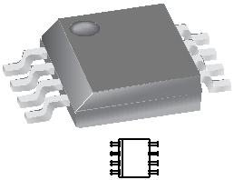

**Description**

The Allegro™ ACS712 provides economical and precise solutions for AC or DC current sensing in industrial, commercial, and communications systems. The device package allows for easy implementation by the customer. Typical applications include motor control, load detection and management, switch-mode power supplies, and overcurrent fault protection. The device is not intended for automotive applications.

The device consists of a precise, low-offset, linear Hall circuit with a copper conduction path located near the surface of the die. Applied current flowing through this copper conduction path generates a magnetic field which the Hall IC converts into a proportional voltage. Device accuracy is optimized through the close proximity of the magnetic signal to the Hall transducer. A precise, proportional voltage is provided by the low-offset, chopper-stabilized BiCMOS Hall IC, which is programmed for accuracy after packaging.

The output of the device has a positive slope (>VIOUT(Q)) when an increasing current flows through the primary copper

conduction path (from pins 1 and 2, to pins 3 and 4), which is the path used for current sampling. The internal resistance of this conductive path is 1.2 mΩ typical, providing low power loss. The thickness of the copper conductor allows survival of

Approximate Scale 1:1

**Typical Application**

|  |  |  |  |  |  |  |  |  |  |  |  |  |  |  |  |  |  |  |  |  |  |  |  |  |  |  |  |
| --- | --- | --- | --- | --- | --- | --- | --- | --- | --- | --- | --- | --- | --- | --- | --- | --- | --- | --- | --- | --- | --- | --- | --- | --- | --- | --- | --- |
|  |  |  |  |  |  | 8 |  |  |  |  |  |  |  | +5 V | | | | | | | | | | | |  |  |
|  |  | 1 | | IP+ | VCC |  |  |  |  |  |  |  |  |  |  |  |  |  |  |  |  |  |  |  |  |  |
|  |  |  | 2 | VIOUT | 7 |  |  |  |  |  |  |  | VOUT | | | | | |  |  |  |  |  |  | CBYP |  |
|  |  |  | IP+ |  | |  |  |  |  |  |  | | |  |  |  |  |
|  |  |  |  |  |  |  |  |  |  |  |  |  |  |  |  |  |  |  |  |  |  |  |  |  |
| IP | | | | ACS712 | | 6 |  |  |  |  |  |  |  |  |  |  |  |  |  |  |  |  |  |  |  | 0.1 μF |  |
|  | |  |  |  |  |  |  |  |  |  |  |  |  |  |  |  |  |  |  |  |
|  | |  |  |  |  |  |  |  |  |  |  |  |  |  |  |  |  |  |  |  |
| 3 | | | | IP– | FILTER |  | |  |  |  |  |  |  |  |  |  |  |  |  |  |  |  |  |  |  |  |
|  |  |  |  |  | CF | | | | | | | | | | | |  |  |
|  |  |  | 4 | IP– | GND | 5 |  |  |  |  |  |  |  | 1 nF | | | | | | | | | | | |  |  |
|  |  |  |  |  |  |  |  |  |  |  |  |  |
|  |  |  |  |  |  |  | |  |  |  |  |  |  |  |  |  |  |  |  |  |  |  |  |  |  |  |
|  |  |  |  |  |  |  |  |  |  |  |  |  |  |  |  |  |  |  |  |  |  |  |  |  |  |  |  |
|  |  |  |  |  |  |  |  |  |  |  |  |  |  |  |  |  |  |  |  |  |  |  |  |  |  |  |  |
|  |  |  |  |  |  |  |  |  |  |  |  |  |  |  |  |  |  |  |  |  |  |  |  |  |  |  |  |

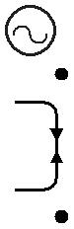

Application 1. The ACS712 outputs an analog signal, VOUT . that varies linearly with the uni- or bi-directional AC or DC primary sampled current, I P , within the range

|  |  |  |
| --- | --- | --- |
| **ACS712** | ***Fully Integrated, Hall Effect-Based Linear Current Sensor IC*** |  |
| ***with 2.1 kVRMS Isolation and a Low-Resistance Current Conductor*** |  |
|  |  |  |

**Description (continued)**

the device at up to 5× overcurrent conditions. The terminals of the conductive path are electrically isolated from the signal leads (pins 5 through 8). This allows the ACS712 to be used in applications requiring electrical isolation without the use of opto-isolators or other costly isolation techniques.

**Selection Guide**

The ACS712 is provided in a small, surface mount SOIC8 package. The leadframe is plated with 100% matte tin, which is compatible with standard lead (Pb) free printed circuit board assembly processes. Internally, the device is Pb-free, except for flip-chip high-temperature Pb-based solder balls, currently exempt from RoHS. The device is fully calibrated prior to shipment from the factory.

|  |  |  |  |  |
| --- | --- | --- | --- | --- |
| **Part Number** | **Packing\*** | **TA** | **Optimized Range, IP** | **Sensitivity, Sens** |
|  |  | **(°C)** | **(A)** | **(Typ) (mV/A)** |
| ACS712ELCTR-05B-T | Tape and reel, 3000 pieces/reel | –40 to 85 | ±5 | 185 |
|  |  |  |  |  |
| ACS712ELCTR-20A-T | Tape and reel, 3000 pieces/reel | –40 to 85 | ±20 | 100 |
|  |  |  |  |  |
| ACS712ELCTR-30A-T | Tape and reel, 3000 pieces/reel | –40 to 85 | ±30 | 66 |
|  |  |  |  |  |
| *Contact Allegro for additional packing options. | |  |  |  |

**Absolute Maximum Ratings**

|  |  |  |  |  |
| --- | --- | --- | --- | --- |
| **Characteristic** | **Symbol** | **Notes** | **Rating** | **Units** |
| Supply Voltage | VCC |  | 8 | V |
| Reverse Supply Voltage | VRCC |  | –0.1 | V |
| Output Voltage | VIOUT |  | 8 | V |
| Reverse Output Voltage | VRIOUT |  | –0.1 | V |
| Output Current Source | IIOUT(Source) |  | 3 | mA |
| Output Current Sink | IIOUT(Sink) |  | 10 | mA |
| Overcurrent Transient Tolerance | IP | 1 pulse, 100 ms | 100 | A |
| Nominal Operating Ambient Temperature | TA | Range E | –40 to 85 | ºC |
| Maximum Junction Temperature | TJ(max) |  | 165 | ºC |
| Storage Temperature | Tstg |  | –65 to 170 | ºC |

**Isolation Characteristics**

|  |  |  |  |  |  |
| --- | --- | --- | --- | --- | --- |
| **Characteristic** | **Symbol** | **Notes** | **Rating** | **Unit** |  |
| Dielectric Strength Test Voltage* | VISO | Agency type-tested for 60 seconds per | 2100 | VAC |  |
| UL standard 60950-1, 1st Edition |  |
| Working Voltage for Basic Isolation | VWFSI | For basic (single) isolation per UL standard | 354 | VDC or Vpk |  |
| 60950-1, 1st Edition |  |
| Working Voltage for Reinforced Isolation | VWFRI | For reinforced (double) isolation per UL standard | 184 | VDC or Vpk |  |
| 60950-1, 1st Edition |  |

* Allegro does not conduct 60-second testing. It is done only during the UL certification process.

|  |  |
| --- | --- |
| **Parameter** | **Specification** |

|  |  |
| --- | --- |
|  | CAN/CSA-C22.2 No. 60950-1-03 |
| Fire and Electric Shock | UL 60950-1:2003 |
|  | EN 60950-1:2001 |

|  |  |  |
| --- | --- | --- |
| **ACS712** | ***Fully Integrated, Hall Effect-Based Linear Current Sensor IC*** |  |
| ***with 2.1 kVRMS Isolation and a Low-Resistance Current Conductor*** |  |
|  |  |  |

**Functional Block Diagram**

+5 V

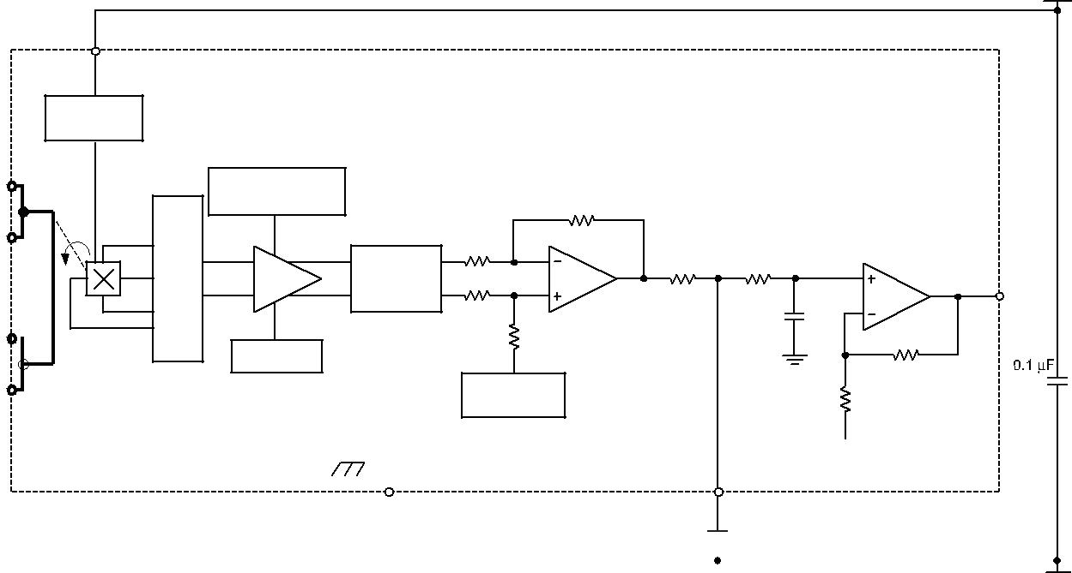

VCC (Pin 8)

Hall Current

Drive

IP+ (Pin 1)

IP+ (Pin 2)

IP− (Pin 3) 

IP−  (Pin 4)

|  |  |
| --- | --- |
| Dynamic Offset | Cancellation |

Sense Temperature

Coefficient Trim

Sense

Trim

|  |  |
| --- | --- |
| Signal | VIOUT |
| Recovery | (Pin 7) |
|  | RF(INT) |

0 Ampere

Offset Adjust

|  |  |  |  |  |  |  |  |  |  |  |  |  |  |  |  |  |
| --- | --- | --- | --- | --- | --- | --- | --- | --- | --- | --- | --- | --- | --- | --- | --- | --- |
|  |  |  |  |  |  |  |  |  |  |  |  |  |  |  |  |  |
|  |  |  |  |  |  |  |  |  |  |  |  |  |  |  |  |  |
|  |  |  |  |  |  |  |  |  |  |  |  |  |  |  |  |  |
|  |  |  |  |  |  |  |  |  |  |  |  |  |  |  |  |  |
| GND | |  | FILTER | | | | | | | | | | | |  |  |
|  |  |  |
| (Pin 5) | |  | (Pin 6) | | | | | | | | | | | |  |  |
|  |  |  |  |  |  |  |  |  |  |  |  |  |  |  |  |  |
|  |  |  |  |  |  |  |  |  |  |  |  |  |  |  |  |  |
|  |  |  |  |  |  |  |  |  |  |  |  |  |  |  |  |  |
|  |  |  |  |  |  |  |  |  |  |  |  |  |  |  |  |  |

**Pin-out Diagram**



|  |  |  |  |  |  |  |
| --- | --- | --- | --- | --- | --- | --- |
| IP+ |  |  |  |  | VCC |  |
| 1 |  |  | 8 |  |
| IP+ |  |  |  |  | VIOUT |  |
| 2 | 7 |  |
| IP– |  |  |  |  | FILTER |  |
| 3 | 6 |  |
| IP– |  |  |  |  | GND |  |
| 4 | 5 |  |
|  |  |  |  |  |  |  |

**Terminal List Table**

|  |  |  |
| --- | --- | --- |
| **Number** | **Name** | **Description** |
| 1 and 2 | IP+ | Terminals for current being sampled; fused internally |
|  |  |  |
| 3 and 4 | IP– | Terminals for current being sampled; fused internally |
|  |  |  |
| 5 | GND | Signal ground terminal |
|  |  |  |
| 6 | FILTER | Terminal for external capacitor that sets bandwidth |
|  |  |  |
| 7 | VIOUT | Analog output signal |
|  |  |  |
| 8 | VCC | Device power supply terminal |
|  |  |  |

|  |  |  |
| --- | --- | --- |
| **ACS712** | ***Fully Integrated, Hall Effect-Based Linear Current Sensor IC*** |  |
| ***with 2.1 kVRMS Isolation and a Low-Resistance Current Conductor*** |  |
|  |  |  |

**COMMON OPERATING CHARACTERISTICS1** over full range of TA, CF= 1 nF, and VCC= 5 V, unless otherwise specified

|  |  |  |  |  |  |  |  |
| --- | --- | --- | --- | --- | --- | --- | --- |
| **Characteristic** | **Symbol** | **Test Conditions** | **Min.** | **Typ.** | **Max.** | **Units** |  |
| **ELECTRICAL CHARACTERISTICS** |  |  |  |  |  |  |  |
| Supply Voltage | VCC |  | 4.5 | 5.0 | 5.5 | V |  |
| Supply Current | ICC | VCC = 5.0 V, output open | – | 10 | 13 | mA |  |
| Output Capacitance Load | CLOAD | VIOUT to GND | – | – | 10 | nF |  |
| Output Resistive Load | RLOAD | VIOUT to GND | 4.7 | – | – | kΩ |  |
| Primary Conductor Resistance | RPRIMARY | TA = 25°C | – | 1.2 | – | mΩ |  |
| Rise Time | tr | IP = IP(max), TA = 25°C, COUT = open | – | 3.5 | – | μs |  |
| Frequency Bandwidth | F | –3 dB, TA = 25°C; IP is 10 A peak-to-peak | – | 80 | – | kHz |  |
| Nonlinearity | ELIN | Over full range of IP | – | 1.5 | – | % |  |
| Symmetry | ESYM | Over full range of IP | 98 | 100 | 102 | % |  |
| Zero Current Output Voltage | VIOUT(Q) | Bidirectional; IP = 0 A, TA = 25°C | – | VCC × | – | V |  |
| 0.5 |  |
| Power-On Time | tPO | Output reaches 90% of steady-state level, TJ = 25°C, 20 A present | – | 35 | – | μs |  |
| on leadframe |  |
| Magnetic Coupling2 |  |  | – | 12 | – | G/A |  |
| Internal Filter Resistance3 | RF(INT) |  |  | 1.7 |  | kΩ |  |

1Device may be operated at higher primary current levels, IP, and ambient, TA , and internal leadframe temperatures, TA , provided that the Maximum Junction Temperature, TJ(max), is not exceeded.

21G = 0.1 mT.

3RF(INT) forms an RC circuit via the FILTER pin.

**COMMON THERMAL CHARACTERISTICS1**

|  |  |  |  |  |  |  |  |
| --- | --- | --- | --- | --- | --- | --- | --- |
|  |  |  | Min. | Typ. | Max. | Units |  |
|  |  |  |  |  |  |  |  |
| Operating Internal Leadframe Temperature | TA | E range | –40 | – | 85 | °C |  |
|  |  |  |  |  | Value | Units |  |
|  |  |  |  |  |  |  |  |
| Junction-to-Lead Thermal Resistance2 | RθJL | Mounted on the Allegro ASEK 712 evaluation board |  |  | 5 | °C/W |  |
| Junction-to-Ambient Thermal Resistance | RθJA | Mounted on the Allegro 85-0322 evaluation board, includes the power con- | | | 23 | °C/W |  |
| sumed by the board |  |  |  |

1Additional thermal information is available on the Allegro website.

2The Allegro evaluation board has 1500 mm2 of 2 oz. copper on each side, connected to pins 1 and 2, and to pins 3 and 4, with thermal vias connect-ing the layers. Performance values include the power consumed by the PCB. Further details on the board are available from the Frequently Asked

Questions document on our website. Further information about board design and thermal performance also can be found in the Applications Informa-tion section of this datasheet.

|  |  |  |
| --- | --- | --- |
| **ACS712** | ***Fully Integrated, Hall Effect-Based Linear Current Sensor IC*** |  |
| ***with 2.1 kVRMS Isolation and a Low-Resistance Current Conductor*** |  |
|  |  |  |

**x05B PERFORMANCE CHARACTERISTICS1** TA= –40°C to 85°C, CF= 1 nF, and VCC= 5 V, unless otherwise specified

|  |  |  |  |  |  |  |  |  |  |
| --- | --- | --- | --- | --- | --- | --- | --- | --- | --- |
| **Characteristic** | **Symbol** |  |  | **Test Conditions** | **Min.** | **Typ.** | **Max.** | **Units** |  |
| Optimized Accuracy Range | IP |  |  |  | –5 | – | 5 | A |  |
| Sensitivity | Sens | Over full range of IP, TA = 25°C | | | 180 | 185 | 190 | mV/A |  |
| Noise | VNOISE(PP) | Peak-to-peak, TA = 25°C, 185 mV/A programmed Sensitivity, | | | – | 21 | – | mV |  |
| CF = 47 nF, COUT = open, 2 kHz bandwidth | | |  |
| Zero Current Output Slope | ∆VOUT(Q) | TA = –40°C to 25°C | | | – | –0.26 | – | mV/°C |  |
| TA = 25°C to 150°C | | | – | –0.08 | – | mV/°C |  |
|  |  |  |
| Sensitivity Slope | ∆Sens | TA = –40°C to 25°C | | | – | 0.054 | – | mV/A/°C |  |
| TA = 25°C to 150°C | | | – | –0.008 | – | mV/A/°C |  |
|  |  |  |
| Total Output Error2 | E | I | P | =±5 A, T = 25°C | – | ±1.5 | – | % |  |
|  | TOT |  | A |  |  |  |  |  |

1Device may be operated at higher primary current levels, IP, and ambient temperatures, TA, provided that the Maximum Junction Temperature, TJ(max), is not exceeded.

2Percentage of IP, with IP = 5 A. Output filtered.

**x20A PERFORMANCE CHARACTERISTICS1** TA= –40°C to 85°C, CF= 1 nF, and VCC= 5 V, unless otherwise specified

|  |  |  |  |  |  |  |  |  |  |  |
| --- | --- | --- | --- | --- | --- | --- | --- | --- | --- | --- |
| **Characteristic** | **Symbol** | |  |  | **Test Conditions** | **Min.** | **Typ.** | **Max.** | **Units** |  |
| Optimized Accuracy Range |  | IP |  |  |  | –20 | – | 20 | A |  |
| Sensitivity | Sens | | Over full range of IP, TA = 25°C | | | 96 | 100 | 104 | mV/A |  |
| Noise | VNOISE(PP) | | Peak-to-peak, TA = 25°C, 100 mV/A programmed Sensitivity, | | | – | 11 | – | mV |  |
| CF = 47 nF, COUT = open, 2 kHz bandwidth | | |  |
| Zero Current Output Slope | ∆VOUT(Q) | | TA = –40°C to 25°C | | | – | –0.34 | – | mV/°C |  |
| TA = 25°C to 150°C | | | – | –0.07 | – | mV/°C |  |
|  |  |  |  |
| Sensitivity Slope | ∆Sens | | TA = –40°C to 25°C | | | – | 0.017 | – | mV/A/°C |  |
| TA = 25°C to 150°C | | | – | –0.004 | – | mV/A/°C |  |
|  |  |  |  |
| Total Output Error2 | E | TOT | I | P | =±20 A, T = 25°C | – | ±1.5 | – | % |  |
|  |  |  | A |  |  |  |  |  |

1Device may be operated at higher primary current levels, IP, and ambient temperatures, TA, provided that the Maximum Junction Temperature,

TJ(max), is not exceeded.

2Percentage of IP, with IP = 20 A. Output filtered.

**x30A PERFORMANCE CHARACTERISTICS1** TA= –40°C to 85°C, CF= 1 nF, and VCC= 5 V, unless otherwise specified

|  |  |  |  |  |  |  |  |  |  |  |  |  |
| --- | --- | --- | --- | --- | --- | --- | --- | --- | --- | --- | --- | --- |
| **Characteristic** | **Symbol** | |  |  |  |  | **Test Conditions** | **Min.** | **Typ.** | **Max.** | **Units** |  |
| Optimized Accuracy Range |  | IP |  |  |  |  |  | –30 | – | 30 | A |  |
| Sensitivity | Sens | | Over full range of IP , TA = 25°C | | | | | 63 | 66 | 69 | mV/A |  |
| Noise | VNOISE(PP) | | Peak-to-peak, TA = 25°C, 66 mV/A programmed Sensitivity, | | | | | – | 7 | – | mV |  |
| C | F | = 47 nF, C | OUT | = open, 2 kHz bandwidth |  |
|  |  |  |  |  |  |  |  |  |  |  |
| Zero Current Output Slope | ∆VOUT(Q) | | TA = –40°C to 25°C | | | | | – | –0.35 | – | mV/°C |  |
| TA | | = 25°C to 150°C | | | – | –0.08 | – | mV/°C |  |
|  |  |  |  |
| Sensitivity Slope | ∆Sens | | TA = –40°C to 25°C | | | | | – | 0.007 | – | mV/A/°C |  |
| TA | | = 25°C to 150°C | | | – | –0.002 | – | mV/A/°C |  |
|  |  |  |  |
| Total Output Error2 | E | TOT | I = ±30 A , T | | | = 25°C | | – | ±1.5 | – | % |  |
|  |  | P | | A |  |  |  |  |  |  |  |

1Device may be operated at higher primary current levels, IP, and ambient temperatures, TA, provided that the Maximum Junction Temperature, TJ(max), is not exceeded.

2Percentage of IP, with IP = 30 A. Output filtered.

|  |  |  |
| --- | --- | --- |
| **ACS712** | ***Fully Integrated, Hall Effect-Based Linear Current Sensor IC*** |  |
| ***with 2.1 kVRMS Isolation and a Low-Resistance Current Conductor*** |  |
|  |  |  |

Characteristic Performance

IP = 5 A, unless otherwise specified

Mean Supply Current versus Ambient Temperature

|  |  |  |  |  |  |  |  |  |  |  |
| --- | --- | --- | --- | --- | --- | --- | --- | --- | --- | --- |
|  | 10.30 |  |  |  |  |  |  |  |  |  |
|  | 10.25 |  |  |  |  |  |  |  |  |  |
|  | 10.20 |  |  |  |  |  |  |  |  |  |
| **(mA)** | 10.15 |  |  |  |  |  |  |  |  |  |
| 10.10 |  |  | VCC = 5 V | |  |  |  |  |  |
| 10.05 |  |  |  |  |  |  |  |
| **CC** | 10.00 |  |  |  |  |  |  |  |  |  |
| **I** |  |  |  |  |  |  |  |  |  |
| **Mean** |  |  |  |  |  |  |  |  |  |
| 9.95 |  |  |  |  |  |  |  |  |  |
| 9.90 |  |  |  |  |  |  |  |  |  |
|  |  |  |  |  |  |  |  |  |  |
|  | 9.85 |  |  |  |  |  |  |  |  |  |
|  | 9.80 |  |  |  |  |  |  |  |  |  |
|  | 9.75 |  |  |  |  |  |  |  |  |  |
|  | -50 | -25 | 0 | 25 | 50 | 75 | 100 | 125 | 150 |  |
|  |  |  |  |  | **TA (°C)** |  |  |  |  |  |

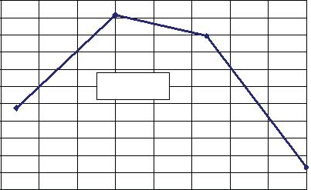Magnetic Offset versus Ambient Temperature

|  |  |  |  |  |  |  |  |  |  |  |
| --- | --- | --- | --- | --- | --- | --- | --- | --- | --- | --- |
|  | 0 |  |  |  |  |  |  |  |  |  |
|  | –0.5 |  |  |  |  |  |  |  |  |  |
|  | –1.0 |  |  |  |  |  |  |  |  |  |
| **(mA)** | –1.5 |  |  |  |  |  |  |  |  |  |
| –2.0 |  | VCC = 5 V; IP = 0 A, | | |  |  |  |  |  |
| –2.5 |  |  |  |  |  |  |
| **OM** |  | After excursion to 20 A | | |  |  |  |  |  |
| **I** | –3.0 |  |  |  |  |  |  |
|  |  |  |  |  |  |  |  |  |  |
|  | –3.5 |  |  |  |  |  |  |  |  |  |
|  | –4.0 |  |  |  |  |  |  |  |  |  |
|  | –4.5 |  |  |  |  |  |  |  |  |  |
|  | –5.0 |  |  |  |  |  |  |  |  |  |
|  | -50 | -25 | 0 | 25 | 50 | 75 | 100 | 125 | 150 |  |
|  |  |  |  |  | **TA (°C)** |  |  |  |  |  |

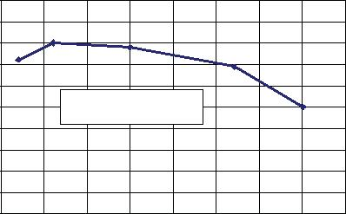Mean Total Output Error versus Ambient Temperature

|  |  |  |  |  |  |  |  |  |  |  |
| --- | --- | --- | --- | --- | --- | --- | --- | --- | --- | --- |
|  | 8 |  |  |  |  |  |  |  |  |  |
|  | 6 |  |  |  |  |  |  |  |  |  |
| **(%)** | 4 |  |  |  |  |  |  |  |  |  |
| 2 |  |  |  |  |  |  |  |  |  |
| **TOT** |  |  |  |  |  |  |  |  |  |
| 0 |  |  |  |  |  |  |  |  |  |
| **E** |  |  |  |  |  |  |  |  |  |
|  | –2 |  |  |  |  |  |  |  |  |  |
|  | –4 |  |  |  |  |  |  |  |  |  |
|  | –6 |  |  |  |  |  |  |  |  |  |
|  | –8 | –25 | 0 | 25 | 50 | 75 | 100 | 125 | 150 |  |
|  | –50 |  |
|  |  |  |  |  | **TA (°C)** |  |  |  |  |  |

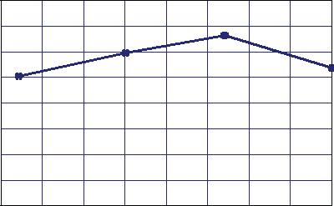

Output Voltage versus Sensed Current

|  |  |  |  |  |  |  |  |  |  |  |  |  |  |  |  |  |  |
| --- | --- | --- | --- | --- | --- | --- | --- | --- | --- | --- | --- | --- | --- | --- | --- | --- | --- |
|  | 4.0 |  |  |  |  |  |  |  |  |  |  |  |  |  |  |  |  |
|  | 3.5 |  |  |  |  |  |  |  |  |  |  |  |  |  |  |  |  |
| **(V)** | 3.0 |  |  | VCC = 5 V | | |  |  |  |  |  |  |  |  |  |  |  |
| 2.5 |  |  |  |  |  |  |  |  |  |  |  |  |  |  |  |  |
| **IOUT** |  |  |  |  |  |  |  |  |  |  |  |  |  |  |  |  |
| 2.0 |  |  |  |  |  |  |  |  |  | T | A | (°C) | |  |  |  |
| **V** |  |  |  |  |  |  |  |  |  |  |  | –40 |  |  |  |
|  | 1.5 |  |  |  |  |  |  |  |  |  |  |  |  |  |  |  |
|  |  |  |  |  |  |  |  |  |  |  |  |  | 25 |  |  |  |
|  | 1.0 |  |  |  |  |  |  |  |  |  |  |  |  | 85 |  |  |  |
|  |  |  |  |  |  |  |  |  |  |  |  |  | 150 |  |  |  |
|  |  |  |  |  |  |  |  |  |  |  |  |  |  |  |  |  |
|  | 0.5 |  |  |  |  |  |  |  |  |  |  |  |  |  |  |  |  |
|  | 0 |  |  |  |  |  | –1 | 0 | 1 | 2 | 3 | 4 | | 5 | 6 | 7 |  |
|  | –7 | –6 | –5 | –4 | –3 | –2 |  |
|  |  |  |  |  |  |  |  | **IP (A)** | |  |  |  |  |  |  |  |  |

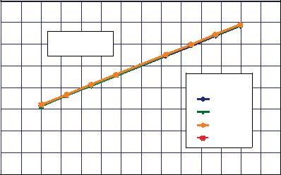0 A Output Voltage versus Ambient Temperature

|  |  |  |  |  |  |  |  |  |  |  |
| --- | --- | --- | --- | --- | --- | --- | --- | --- | --- | --- |
|  | 2520 |  |  |  |  |  |  |  |  |  |
|  | 2515 |  |  |  |  |  |  |  |  |  |
| **(mV)** | 2510 |  |  |  | IP = 0 A | |  |  |  |  |
| 2505 |  |  |  |  |  |  |  |  |  |
| **IOUT(Q)** |  |  |  |  |  |  |  |  |  |
| 2500 |  |  |  |  |  |  |  |  |  |
| **V** |  |  |  |  |  |  |  |  |  |  |
|  | 2495 |  |  |  |  |  |  |  |  |  |
|  | 2490 |  |  |  |  |  |  |  |  |  |
|  | 2485 |  |  |  |  |  |  |  |  |  |
|  | -50 | -25 | 0 | 25 | 50 | 75 | 100 | 125 | 150 |  |
|  |  |  |  |  | **TA (°C)** |  |  |  |  |  |

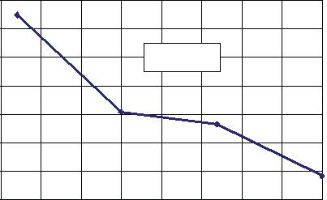

Supply Current versus Supply Voltage

|  |  |  |  |  |  |  |  |  |  |  |  |  |
| --- | --- | --- | --- | --- | --- | --- | --- | --- | --- | --- | --- | --- |
|  | 10.9 |  |  |  |  |  |  |  |  |  |  |  |
|  | 10.8 |  |  |  |  |  |  |  |  |  |  |  |
|  | 10.7 |  |  |  |  |  |  |  |  |  |  |  |
| **(mA)** | 10.6 |  |  |  |  |  |  |  |  |  |  |  |
| 10.5 |  |  |  |  |  |  |  |  |  |  |  |
| **CC** |  |  |  |  |  |  |  |  |  |  |  |
|  |  |  |  |  |  |  |  |  |  |  |  |
| **I** | 10.4 |  |  |  |  |  |  |  |  |  |  |  |
|  |  |  |  |  |  |  |  |  |  |  |  |
|  | 10.3 |  |  |  |  |  |  |  |  |  |  |  |
|  | 10.2 |  |  |  |  |  |  |  |  |  |  |  |
|  | 10.1 |  |  |  |  |  |  |  |  |  |  |  |
|  | 10.0 |  |  |  |  | 5.0 | 5.1 | 5.2 | 5.3 | 5.4 | 5.5 |  |
|  | 4.5 | 4.6 | 4.7 | 4.8 | 4.9 |  |

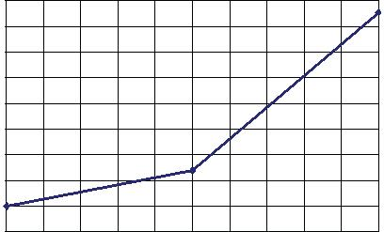**VCC (V)**

Nonlinearity versus Ambient Temperature

|  |  |  |  |  |  |  |  |  |  |  |
| --- | --- | --- | --- | --- | --- | --- | --- | --- | --- | --- |
|  | 0.6 |  |  |  |  |  |  |  |  |  |
|  | 0.5 |  |  |  |  |  |  |  |  |  |
| **(%)** | 0.4 |  | VCC = 5 V | |  |  |  |  |  |  |
|  |  |  |  |  |  |  |  |  |  |
| **LIN** | 0.3 |  |  |  |  |  |  |  |  |  |
| **E** |  |  |  |  |  |  |  |  |  |
|  | 0.2 |  |  |  |  |  |  |  |  |  |
|  | 0.1 |  |  |  |  |  |  |  |  |  |
|  | 0 | –25 | 0 | 25 | 50 | 75 | 100 | 125 | 150 |  |
|  | –50 |  |
|  |  |  |  |  | **TA (°C)** |  |  |  |  |  |

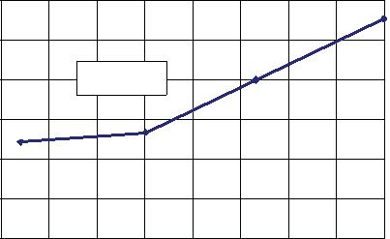Sensitivity versus Ambient Temperature

|  |  |  |  |  |  |  |  |  |  |  |
| --- | --- | --- | --- | --- | --- | --- | --- | --- | --- | --- |
|  | 186.5 |  |  |  |  |  |  |  |  |  |
|  | 186.0 |  |  |  |  |  |  |  |  |  |
| **(mV/A)** | 185.5 |  |  |  |  |  |  |  |  |  |
| 185.0 |  |  |  |  |  |  |  |  |  |
| 184.5 |  |  |  |  |  |  |  |  |  |
| **Sens** |  |  |  |  |  |  |  |  |  |
| 184.0 |  |  |  |  |  |  |  |  |  |
| 183.5 |  |  |  |  |  |  |  |  |  |
|  |  |  |  |  |  |  |  |  |  |
|  | 183.0 |  |  |  |  |  |  |  |  |  |
|  | 182.5 |  |  |  |  |  |  |  |  |  |
|  | 182.0 |  |  |  |  |  |  |  |  |  |
|  | 181.5 |  |  |  |  |  |  |  |  |  |
|  | 181.0 |  |  |  |  | 75 | 100 | 125 | 150 |  |
|  | –50 | –25 | 0 | 25 | 50 |  |
|  |  |  |  |  | **TA (°C)** |  |  |  |  |  |

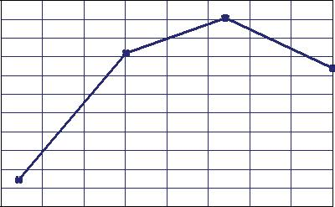

Sensitivity versus Sensed Current

|  |  |  |  |  |  |  |  |  |
| --- | --- | --- | --- | --- | --- | --- | --- | --- |
|  | 200.00 |  |  |  |  |  |  |  |
|  | 190.00 |  |  |  |  |  |  |  |
| **(mV/A)** | 180.00 |  |  |  |  |  |  |  |
| 170.00 |  |  |  |  |  |  |  |
| 160.00 |  |  | TA (°C) |  |  |  |  |
| **Sens** |  |  |  |  |  |  |
| 150.00 |  |  | –40 |  |  |  |  |
|  | 140.00 |  |  | 25 |  |  |  |  |
|  |  |  | 85 |  |  |  |  |
|  | 130.00 |  |  |  |  |  |  |
|  |  |  | 150 |  |  |  |  |
|  | 120.00 |  |  |  |  |  |  |
|  |  |  |  |  |  |  |  |
|  | 110.00 |  |  |  |  |  |  |  |
|  | 100.00 |  |  |  |  |  |  |  |
|  | -6 | -4 | -2 | 0 | 2 | 4 | 6 |  |
|  |  |  |  | **Ip (A)** |  |  |  |  |

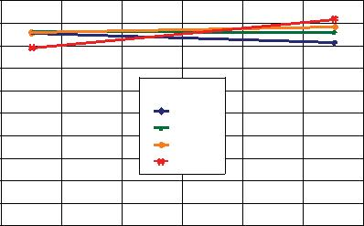

0 A Output Voltage Current versus Ambient Temperature

|  |  |  |  |  |  |  |  |  |  |  |
| --- | --- | --- | --- | --- | --- | --- | --- | --- | --- | --- |
|  | 0.20 |  |  |  |  |  |  |  |  |  |
|  | 0.15 |  |  |  |  |  |  |  |  |  |
|  | 0.10 |  |  |  |  | IP = 0 A | |  |  |  |
| **(A)** | 0.05 |  |  |  |  |  |  |  |  |  |
| **OUT(Q)** |  |  |  |  |  |  |  |  |  |
| 0 |  |  |  |  |  |  |  |  |  |
| **I** |  |  |  |  |  |  |  |  |  |  |
|  | –0.05 |  |  |  |  |  |  |  |  |  |
|  | –0.10 |  |  |  |  |  |  |  |  |  |
|  | –0.15 |  |  |  |  |  |  |  |  |  |
|  | -50 | -25 | 0 | 25 | 50 | 75 | 100 | 125 | 150 |  |
|  |  |  |  |  | **TA (°C)** |  |  |  |  |  |

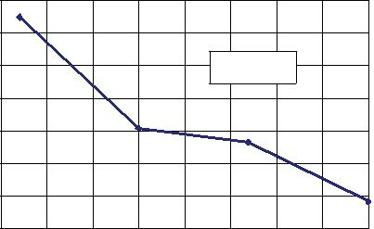

|  |  |  |
| --- | --- | --- |
| **ACS712** | ***Fully Integrated, Hall Effect-Based Linear Current Sensor IC*** |  |
| ***with 2.1 kVRMS Isolation and a Low-Resistance Current Conductor*** |  |
|  |  |  |

Characteristic Performance

IP = 20 A, unless otherwise specified

Mean Supply Current versus Ambient Temperature

|  |  |  |  |  |  |  |  |  |  |  |
| --- | --- | --- | --- | --- | --- | --- | --- | --- | --- | --- |
|  | 9.7 |  |  |  |  |  |  |  |  |  |
|  | 9.6 |  |  |  |  |  |  |  |  |  |
| **(mA)** | 9.5 |  |  |  |  |  |  |  |  |  |
|  |  |  |  |  |  |  |  |  |  |
| **CC** | 9.4 |  |  | VCC = 5 V | |  |  |  |  |  |
| **I** |  |  |  |  |  |  |  |
| **Mean** | 9.3 |  |  |  |  |  |  |  |  |  |
|  |  |  |  |  |  |  |  |  |  |
|  | 9.2 |  |  |  |  |  |  |  |  |  |
|  | 9.1 |  |  |  |  |  |  |  |  |  |
|  | -50 | -25 | 0 | 25 | 50 | 75 | 100 | 125 | 150 |  |
|  |  |  |  |  | **TA (°C)** |  |  |  |  |  |

Magnetic Offset versus Ambient Temperature

|  |  |  |  |  |  |  |  |  |  |  |
| --- | --- | --- | --- | --- | --- | --- | --- | --- | --- | --- |
|  | 0 |  |  |  |  |  |  |  |  |  |
|  | –0.5 |  |  |  |  |  |  |  |  |  |
|  | –1.0 |  |  |  |  |  |  |  |  |  |
| **(mA)** | –1.5 |  |  |  |  |  |  |  |  |  |
| –2.0 |  |  |  |  |  |  |  |  |  |
| –2.5 |  | VCC = 5 V; IP = 0 A, | | |  |  |  |  |  |
| **OM** |  |  |  |  |  |  |
| **I** | –3.0 |  | After excursion to 20 A | | |  |  |  |  |  |
|  |  |  |  |  |  |  |
|  | –3.5 |  |  |  |  |  |  |  |  |  |
|  | –4.0 |  |  |  |  |  |  |  |  |  |
|  | –4.5 |  |  |  |  |  |  |  |  |  |
|  | –5.0 |  |  |  |  |  |  |  |  |  |
|  | -50 | -25 | 0 | 25 | 50 | 75 | 100 | 125 | 150 |  |
|  |  |  |  |  | **TA (°C)** |  |  |  |  |  |

Mean Total Output Error versus Ambient Temperature

|  |  |  |  |  |  |  |  |  |  |  |
| --- | --- | --- | --- | --- | --- | --- | --- | --- | --- | --- |
|  | 8 |  |  |  |  |  |  |  |  |  |
|  | 6 |  |  |  |  |  |  |  |  |  |
|  | 4 |  |  |  |  |  |  |  |  |  |
| **(%)** | 2 |  |  |  |  |  |  |  |  |  |
| 0 |  |  |  |  |  |  |  |  |  |
| **TOT** |  |  |  |  |  |  |  |  |  |
|  |  |  |  |  |  |  |  |  |  |
| **E** | –2 |  |  |  |  |  |  |  |  |  |
|  |  |  |  |  |  |  |  |  |  |
|  | –4 |  |  |  |  |  |  |  |  |  |
|  | –6 |  |  |  |  |  |  |  |  |  |
|  | –8 | –25 | 0 | 25 | 50 | 75 | 100 | 125 | 150 |  |
|  | –50 |  |
|  |  |  |  |  | **TA (°C)** |  |  |  |  |  |

Output Voltage versus Sensed Current

|  |  |  |  |  |  |  |  |  |  |  |  |  |
| --- | --- | --- | --- | --- | --- | --- | --- | --- | --- | --- | --- | --- |
|  | 5.0 |  |  |  |  |  |  |  |  |  |  |  |
|  | 4.5 |  |  |  |  |  |  |  |  |  |  |  |
|  | 4.0 |  |  |  |  |  |  |  |  |  |  |  |
|  | 3.5 |  |  | VCC = 5 V | |  |  |  |  |  |  |  |
| **(V)** | 3.0 |  |  |  |  |  |  |  | TA (°C) |  |  |  |
| 2.5 |  |  |  |  |  |  |  |  |  |  |
| **IOUT** |  |  |  |  |  |  |  |  |  |  |
| 2.0 |  |  |  |  |  |  |  | –40 |  |  |  |
| **V** |  |  |  |  |  |  |  | –20 |  |  |  |
|  | 1.5 |  |  |  |  |  |  |  |  |  |  |
|  |  |  |  |  |  |  |  | 25 |  |  |  |
|  | 1.0 |  |  |  |  |  |  |  | 85 |  |  |  |
|  | 0.5 |  |  |  |  |  |  |  | 125 |  |  |  |
|  |  |  |  |  |  |  |  |  |  |  |  |
|  | 0 |  |  |  |  |  | 5 | 10 | 15 | 20 | 25 |  |
|  | –25 | –20 | –15 | –10 | –5 | 0 |  |
|  |  |  |  |  |  | **IP (A)** |  |  |  |  |  |  |

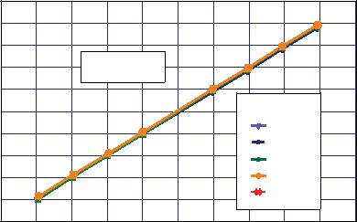

0 A Output Voltage versus Ambient Temperature

|  |  |  |  |  |  |  |  |  |  |  |
| --- | --- | --- | --- | --- | --- | --- | --- | --- | --- | --- |
|  | 2525 |  |  |  |  |  |  |  |  |  |
|  | 2520 |  |  |  |  |  |  |  |  |  |
|  | 2515 |  |  |  |  |  |  |  |  |  |
| **(mV)** | 2510 |  |  |  | IP = 0 A | |  |  |  |  |
|  |  |  |  |  |  |  |  |  |  |
| **IOUT(Q)** | 2505 |  |  |  |  |  |  |  |  |  |
| 2500 |  |  |  |  |  |  |  |  |  |
| **V** |  |  |  |  |  |  |  |  |  |
|  | 2495 |  |  |  |  |  |  |  |  |  |
|  | 2490 |  |  |  |  |  |  |  |  |  |
|  | 2485 |  |  |  |  |  |  |  |  |  |
|  | -50 | -25 | 0 | 25 | 50 | 75 | 100 | 125 | 150 |  |
|  |  |  |  |  | **TA (°C)** |  |  |  |  |  |

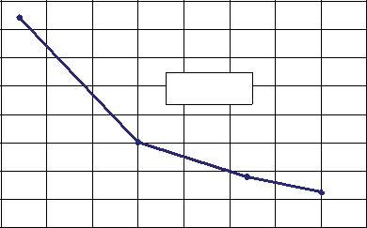

Supply Current versus Supply Voltage

|  |  |  |  |  |  |  |  |  |  |  |  |  |
| --- | --- | --- | --- | --- | --- | --- | --- | --- | --- | --- | --- | --- |
|  | 10.4 |  |  |  |  |  |  |  |  |  |  |  |
|  | 10.2 |  |  |  |  |  |  |  |  |  |  |  |
| **(mA)** | 10.0 |  |  |  |  |  |  |  |  |  |  |  |
| 9.8 |  |  |  |  |  |  |  |  |  |  |  |
| **CC** |  |  |  |  |  |  |  |  |  |  |  |
|  |  |  |  |  |  |  |  |  |  |  |  |
| **I** | 9.6 |  |  |  |  |  |  |  |  |  |  |  |
|  |  |  |  |  |  |  |  |  |  |  |  |
|  | 9.4 |  |  |  |  |  |  |  |  |  |  |  |
|  | 9.2 |  |  |  |  |  |  |  |  |  |  |  |
|  | 9.0 |  |  |  |  | 5.0 | 5.1 | 5.2 | 5.3 | 5.4 | 5.5 |  |
|  | 4.5 | 4.6 | 4.7 | 4.8 | 4.9 |  |

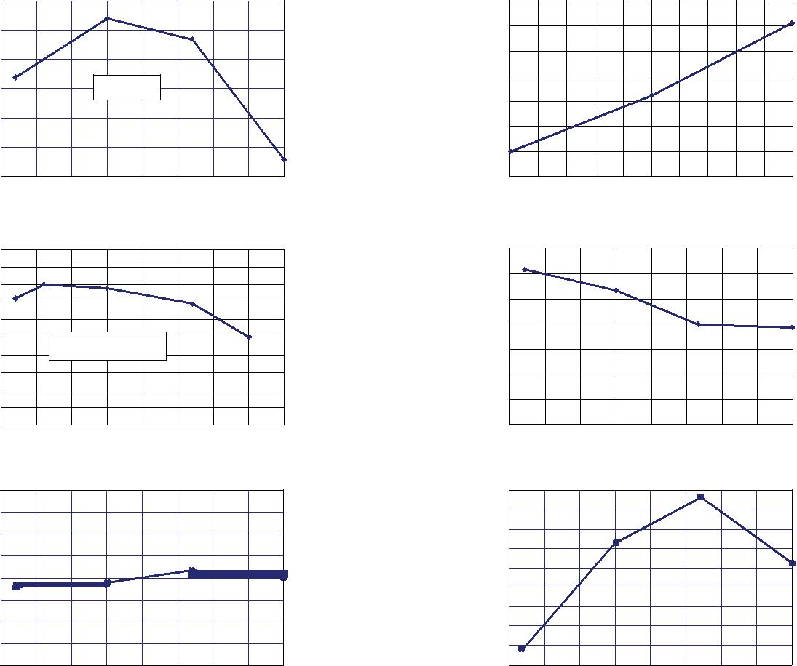**VCC (V)**

Nonlinearity versus Ambient Temperature

|  |  |  |  |  |  |  |  |  |  |  |
| --- | --- | --- | --- | --- | --- | --- | --- | --- | --- | --- |
|  | 0.35 |  |  |  |  |  |  |  |  |  |
|  | 0.30 |  |  |  |  |  |  |  |  |  |
| **(%)** | 0.25 |  |  |  |  |  |  |  |  |  |
| 0.20 |  |  |  |  |  |  |  |  |  |
| **LIN** |  |  |  |  |  |  |  |  |  |
|  |  |  |  |  |  |  |  |  |  |
| **E** | 0.15 |  |  |  |  |  |  |  |  |  |
|  |  |  |  |  |  |  |  |  |  |
|  | 0.10 |  |  |  |  |  |  |  |  |  |
|  | 0.05 |  |  |  |  |  |  |  |  |  |
|  | 0 |  |  |  |  | 75 | 100 | 125 | 150 |  |
|  | –50 | –25 | 0 | 25 | 50 |  |
|  |  |  |  |  | **TA (°C)** |  |  |  |  |  |

Sensitivity versus Ambient Temperature

|  |  |  |  |  |  |  |  |  |  |  |
| --- | --- | --- | --- | --- | --- | --- | --- | --- | --- | --- |
|  | 100.8 |  |  |  |  |  |  |  |  |  |
|  | 100.6 |  |  |  |  |  |  |  |  |  |
|  | 100.4 |  |  |  |  |  |  |  |  |  |
| **(mV/A)** | 100.2 |  |  |  |  |  |  |  |  |  |
| 100.0 |  |  |  |  |  |  |  |  |  |
| **Sens** | 99.8 |  |  |  |  |  |  |  |  |  |
| 99.6 |  |  |  |  |  |  |  |  |  |
|  |  |  |  |  |  |  |  |  |  |
|  | 99.4 |  |  |  |  |  |  |  |  |  |
|  | 99.2 |  |  |  |  |  |  |  |  |  |
|  | 99.0 |  |  |  |  | 75 | 100 | 125 | 150 |  |
|  | –50 | –25 | 0 | 25 | 50 |  |
|  |  |  |  |  | **TA (°C)** |  |  |  |  |  |

Sensitivity versus Sensed Current

|  |  |  |  |  |  |  |  |  |  |  |  |  |
| --- | --- | --- | --- | --- | --- | --- | --- | --- | --- | --- | --- | --- |
|  | 110.00 |  |  |  |  |  |  | TA (°C) | |  |  |  |
|  | 108.00 |  |  |  |  |  |  |  |  |  |
|  | 106.00 |  |  |  |  |  |  |  | –40 |  |  |  |
|  |  |  |  |  |  |  |  | 25 |  |  |  |
|  | 104.00 |  |  |  |  |  |  |  |  |  |  |
| **(mV/A)** |  |  |  |  |  |  |  | 85 |  |  |  |
| 102.00 |  |  |  |  |  |  |  | 150 |  |  |  |
| 100.00 |  |  |  |  |  |  |  |  |  |  |  |
| **Sens** |  |  |  |  |  |  |  |  |  |  |  |
| 98.00 |  |  |  |  |  |  |  |  |  |  |  |
| 96.00 |  |  |  |  |  |  |  |  |  |  |  |
|  |  |  |  |  |  |  |  |  |  |  |  |
|  | 94.00 |  |  |  |  |  |  |  |  |  |  |  |
|  | 92.00 |  |  |  |  |  |  |  |  |  |  |  |
|  | 90.00 | –20 | –15 | –10 | –5 | 0 | 5 | 10 | 15 | 20 | 25 |  |
|  | –25 |  |

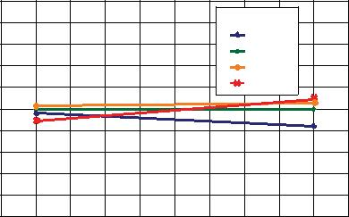**Ip (A)**

0 A Output Voltage Current versus Ambient Temperature

|  |  |  |  |  |  |  |  |  |  |  |
| --- | --- | --- | --- | --- | --- | --- | --- | --- | --- | --- |
|  | 0.25 |  |  |  |  |  |  |  |  |  |
|  | 0.20 |  |  |  |  |  |  |  |  |  |
|  | 0.15 |  |  |  |  |  |  |  |  |  |
| **(A)** | 0.10 |  |  |  | IP = 0 A | |  |  |  |  |
|  |  |  |  |  |  |  |  |  |  |
| **OUT(Q)** | 0.05 |  |  |  |  |  |  |  |  |  |
| 0 |  |  |  |  |  |  |  |  |  |
| **I** |  |  |  |  |  |  |  |  |  |
|  |  |  |  |  |  |  |  |  |  |
|  | –0.05 |  |  |  |  |  |  |  |  |  |
|  | –0.10 |  |  |  |  |  |  |  |  |  |
|  | –0.15 |  |  |  |  |  |  |  |  |  |
|  | -50 | -25 | 0 | 25 | 50 | 75 | 100 | 125 | 150 |  |
|  |  |  |  |  | **TA (°C)** |  |  |  |  |  |

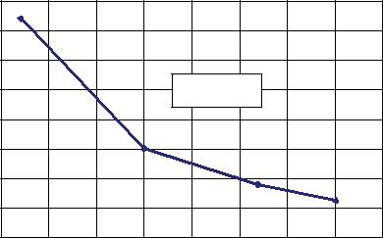

|  |  |  |
| --- | --- | --- |
| **ACS712** | ***Fully Integrated, Hall Effect-Based Linear Current Sensor IC*** |  |
| ***with 2.1 kVRMS Isolation and a Low-Resistance Current Conductor*** |  |
|  |  |  |

Characteristic Performance

IP = 30 A, unless otherwise specified

Mean Supply Current versus Ambient Temperature

|  |  |  |  |  |  |  |  |  |  |  |
| --- | --- | --- | --- | --- | --- | --- | --- | --- | --- | --- |
|  | 9.6 |  |  |  |  |  |  |  |  |  |
|  | 9.5 |  |  |  |  |  |  |  |  |  |
| **(mA)** | 9.4 |  |  |  |  |  |  |  |  |  |
| 9.3 |  |  | VCC = 5 V | |  |  |  |  |  |
| **CC** | 9.2 |  |  |  |  |  |  |  |  |  |
| **I** |  |  |  |  |  |  |  |  |  |
| **Mean** |  |  |  |  |  |  |  |  |  |
| 9.1 |  |  |  |  |  |  |  |  |  |
|  | 9.0 |  |  |  |  |  |  |  |  |  |
|  | 8.9 |  |  |  |  |  |  |  |  |  |
|  | -50 | -25 | 0 | 25 | 50 | 75 | 100 | 125 | 150 |  |
|  |  |  |  |  | **TA (°C)** |  |  |  |  |  |

Magnetic Offset versus Ambient Temperature

|  |  |  |  |  |  |  |  |  |  |  |
| --- | --- | --- | --- | --- | --- | --- | --- | --- | --- | --- |
|  | 0 |  |  |  |  |  |  |  |  |  |
|  | –0.5 |  |  |  |  |  |  |  |  |  |
|  | –1.0 |  |  |  |  |  |  |  |  |  |
| **(mA)** | –1.5 |  |  |  |  |  |  |  |  |  |
| –2.0 |  |  |  |  |  |  |  |  |  |
| –2.5 |  | VCC = 5 V; IP = 0 A, | | |  |  |  |  |  |
| **OM** |  |  |  |  |  |  |
| **I** | –3.0 |  | After excursion to 20 A | | |  |  |  |  |  |
|  |  |  |  |  |  |  |
|  | –3.5 |  |  |  |  |  |  |  |  |  |
|  | –4.0 |  |  |  |  |  |  |  |  |  |
|  | –4.5 |  |  |  |  |  |  |  |  |  |
|  | –5.0 |  |  |  |  |  |  |  |  |  |
|  | -50 | -25 | 0 | 25 | 50 | 75 | 100 | 125 | 150 |  |
|  |  |  |  |  | **TA (°C)** |  |  |  |  |  |

Mean Total Output Error versus Ambient Temperature

|  |  |  |  |  |  |  |  |  |  |  |
| --- | --- | --- | --- | --- | --- | --- | --- | --- | --- | --- |
|  | 8 |  |  |  |  |  |  |  |  |  |
|  | 6 |  |  |  |  |  |  |  |  |  |
| **(%)** | 4 |  |  |  |  |  |  |  |  |  |
| 2 |  |  |  |  |  |  |  |  |  |
| **TOT** |  |  |  |  |  |  |  |  |  |
| 0 |  |  |  |  |  |  |  |  |  |
| **E** |  |  |  |  |  |  |  |  |  |
|  | –2 |  |  |  |  |  |  |  |  |  |
|  | –4 |  |  |  |  |  |  |  |  |  |
|  | –6 |  |  |  |  |  |  |  |  |  |
|  | –8 | –25 | 0 | 25 | 50 | 75 | 100 | 125 | 150 |  |
|  | –50 |  |
|  |  |  |  |  | **TA (°C)** |  |  |  |  |  |

Output Voltage versus Sensed Current

|  |  |  |  |  |  |  |  |  |  |  |
| --- | --- | --- | --- | --- | --- | --- | --- | --- | --- | --- |
|  | 5.0 |  |  |  |  |  |  |  |  |  |
|  | 4.5 |  |  |  |  |  |  |  |  |  |
|  | 4.0 |  |  |  |  |  |  |  |  |  |
| **(V)** | 3.5 |  | VCC = 5 V |  |  |  |  |  |  |  |
| 3.0 |  |  |  |  |  |  |  |  |  |
| **IOUT** |  |  |  |  | T |  | (°C) |  |  |
| 2.5 |  |  |  |  | A |  |  |
| **V** |  |  |  |  |  | –40 |  |  |
|  | 2.0 |  |  |  |  |  |  |  |  |
|  |  |  |  |  |  |  | –20 |  |  |
|  | 1.5 |  |  |  |  |  |  |  |  |
|  |  |  |  |  |  |  | 25 |  |  |
|  | 1.0 |  |  |  |  |  |  | 85 |  |  |
|  | 0.5 |  |  |  |  |  |  | 125 |  |  |
|  |  |  |  |  |  |  |  |  |  |
|  | 0 |  |  |  |  |  |  |  | 30 |  |
|  | –30 | –20 | –10 | 0 | 10 | 20 | | |  |
|  |  |  |  | **IP (A)** |  |  |  |  |  |  |

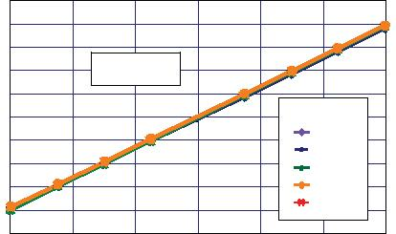0 A Output Voltage versus Ambient Temperature

|  |  |  |  |  |  |  |  |  |  |  |
| --- | --- | --- | --- | --- | --- | --- | --- | --- | --- | --- |
|  | 2535 |  |  |  |  |  |  |  |  |  |
|  | 2530 |  |  |  |  |  |  |  |  |  |
|  | 2525 |  |  |  |  |  |  |  |  |  |
| **(mV)** | 2520 |  |  |  | IP = 0 A | |  |  |  |  |
| 2515 |  |  |  |  |  |  |  |
| **IOUT(Q)** | 2510 |  |  |  |  |  |  |  |  |  |
| 2505 |  |  |  |  |  |  |  |  |  |
| **V** |  |  |  |  |  |  |  |  |  |
|  | 2500 |  |  |  |  |  |  |  |  |  |
|  | 2495 |  |  |  |  |  |  |  |  |  |
|  | 2490 |  |  |  |  |  |  |  |  |  |
|  | 2485 |  |  |  |  |  |  |  |  |  |
|  | -50 | -25 | 0 | 25 | 50 | 75 | 100 | 125 | 150 |  |
|  |  |  |  |  | **TA (°C)** |  |  |  |  |  |

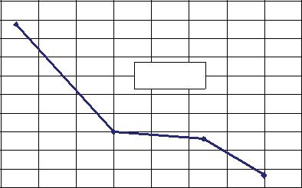

Supply Current versus Supply Voltage

|  |  |  |  |  |  |  |  |  |  |  |  |  |
| --- | --- | --- | --- | --- | --- | --- | --- | --- | --- | --- | --- | --- |
|  | 10.2 |  |  |  |  |  |  |  |  |  |  |  |
|  | 10.0 |  |  |  |  |  |  |  |  |  |  |  |
| **(mA)** | 9.8 |  |  |  |  |  |  |  |  |  |  |  |
|  |  |  |  |  |  |  |  |  |  |  |  |
| **CC** | 9.6 |  |  |  |  |  |  |  |  |  |  |  |
| **I** |  |  |  |  |  |  |  |  |  |  |  |
|  | 9.4 |  |  |  |  |  |  |  |  |  |  |  |
|  | 9.2 |  |  |  |  |  |  |  |  |  |  |  |
|  | 9.0 |  |  |  |  | 5.0 | 5.1 | 5.2 | 5.3 | 5.4 | 5.5 |  |
|  | 4.5 | 4.6 | 4.7 | 4.8 | 4.9 |  |

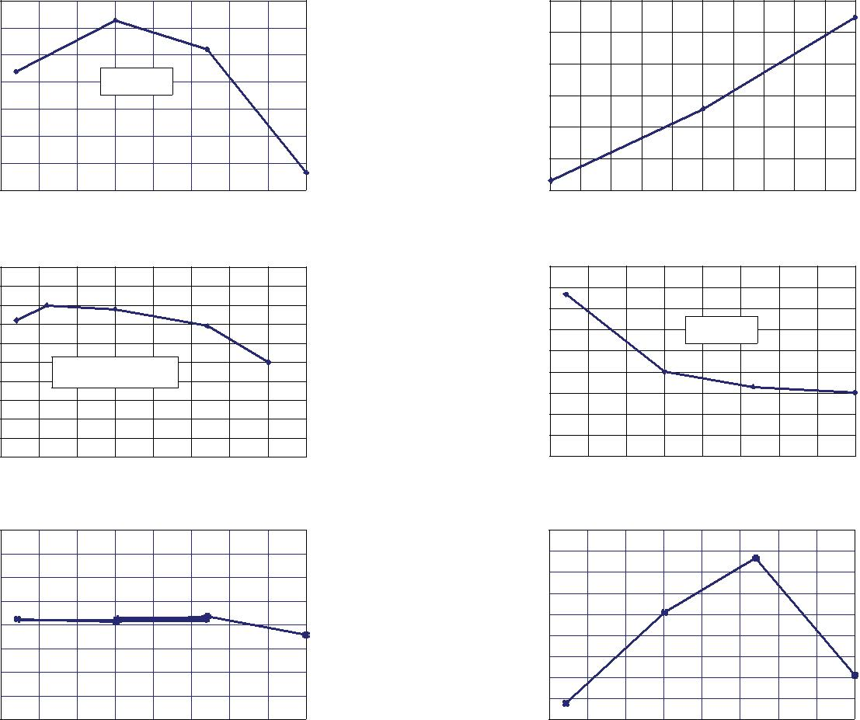**VCC (V)**

Nonlinearity versus Ambient Temperature

|  |  |  |  |  |  |  |  |  |  |  |
| --- | --- | --- | --- | --- | --- | --- | --- | --- | --- | --- |
|  | 0.45 |  |  |  |  |  |  |  |  |  |
|  | 0.40 |  |  |  |  |  |  |  |  |  |
|  | 0.35 |  |  |  |  |  |  |  |  |  |
| **(%)** | 0.30 |  |  |  | VCC = 5 V | |  |  |  |  |
| 0.25 |  |  |  |  |  |  |  |  |  |
| **LIN** |  |  |  |  |  |  |  |  |  |
|  |  |  |  |  |  |  |  |  |  |
| **E** | 0.20 |  |  |  |  |  |  |  |  |  |
|  |  |  |  |  |  |  |  |  |  |
|  | 0.15 |  |  |  |  |  |  |  |  |  |
|  | 0.10 |  |  |  |  |  |  |  |  |  |
|  | 0.05 |  |  |  |  |  |  |  |  |  |
|  | 0 |  |  |  |  | 75 | 100 | 125 | 150 |  |
|  | –50 | –25 | 0 | 25 | 50 |  |
|  |  |  |  |  | **TA (°C)** |  |  |  |  |  |

Sensitivity versus Ambient Temperature

|  |  |  |  |  |  |  |  |  |  |  |
| --- | --- | --- | --- | --- | --- | --- | --- | --- | --- | --- |
|  | 66.6 |  |  |  |  |  |  |  |  |  |
|  | 66.5 |  |  |  |  |  |  |  |  |  |
| **(mV/A)** | 66.4 |  |  |  |  |  |  |  |  |  |
| 66.3 |  |  |  |  |  |  |  |  |  |
| **Sens** | 66.2 |  |  |  |  |  |  |  |  |  |
| 66.1 |  |  |  |  |  |  |  |  |  |
|  |  |  |  |  |  |  |  |  |  |
|  | 66.0 |  |  |  |  |  |  |  |  |  |
|  | 65.9 |  |  |  |  |  |  |  |  |  |
|  | 65.8 |  |  |  |  |  |  |  |  |  |
|  | 65.7 |  |  |  |  | 75 | 100 | 125 | 150 |  |
|  | –50 | –25 | 0 | 25 | 50 |  |
|  |  |  |  |  | **TA (°C)** |  |  |  |  |  |

Sensitivity versus Sensed Current

|  |  |  |  |  |  |  |  |  |
| --- | --- | --- | --- | --- | --- | --- | --- | --- |
|  | 70.00 |  |  |  |  |  |  |  |
|  | 69.00 |  |  |  |  |  |  |  |
| **(mV/A)** | 68.00 |  |  |  |  |  |  |  |
| 67.00 |  |  |  |  |  |  |  |
| 66.00 |  |  |  |  |  |  |  |
| **Sens** |  |  |  |  |  |  |  |
| 65.00 |  |  |  |  | TA (°C) |  |  |
|  | 64.00 |  |  |  |  |  |  |
|  | 63.00 |  |  |  |  | –40 |  |  |
|  |  |  |  |  | 25 |  |  |
|  | 62.00 |  |  |  |  |  |  |
|  |  |  |  |  | 85 |  |  |
|  | 61.00 |  |  |  |  | 150 |  |  |
|  | 60.00 |  |  |  |  |  | 30 |  |
|  | –30 | –20 | –10 | 0 | 10 | 20 |  |
|  |  |  |  | **Ip (A)** |  |  |  |  |

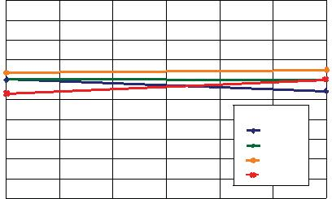

0 A Output Voltage Current versus Ambient Temperature

|  |  |  |  |  |  |  |  |  |  |  |
| --- | --- | --- | --- | --- | --- | --- | --- | --- | --- | --- |
|  | 0.35 |  |  |  |  |  |  |  |  |  |
|  | 0.30 |  |  |  |  |  |  |  |  |  |
|  | 0.25 |  |  |  |  |  |  |  |  |  |
| **(A)** | 0.20 |  |  |  | IP = 0 A | |  |  |  |  |
| 0.15 |  |  |  |  |  |  |  |
| **OUT(Q)** | 0.10 |  |  |  |  |  |  |  |  |  |
| 0.05 |  |  |  |  |  |  |  |  |  |
| **I** |  |  |  |  |  |  |  |  |  |
|  | 0 |  |  |  |  |  |  |  |  |  |
|  | –0.05 |  |  |  |  |  |  |  |  |  |
|  | –0.10 |  |  |  |  |  |  |  |  |  |
|  | –0.15 |  |  |  |  |  |  |  |  |  |
|  | -50 | -25 | 0 | 25 | 50 | 75 | 100 | 125 | 150 |  |
|  |  |  |  |  | **TA (°C)** |  |  |  |  |  |

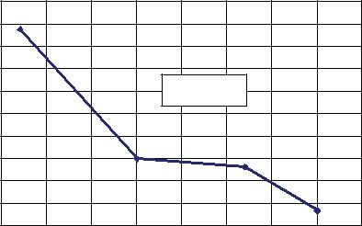

|  |  |  |
| --- | --- | --- |
| **ACS712** | ***Fully Integrated, Hall Effect-Based Linear Current Sensor IC*** |  |
| ***with 2.1 kVRMS Isolation and a Low-Resistance Current Conductor*** |  |
|  |  |  |

**Definitions of Accuracy Characteristics**

**Sensitivity (Sens).** The change in device output in response to a1 A change through the primary conductor. The sensitivity is the product of the magnetic circuit sensitivity (G / A) and the linear IC amplifier gain (mV/G). The linear IC amplifier gain is pro-grammed at the factory to optimize the sensitivity (mV/A) for the full-scale current of the device.

**Noise (VNOISE).** The product of the linear IC amplifier gain(mV/G) and the noise floor for the Allegro Hall effect linear IC

(≈1 G). The noise floor is derived from the thermal and shot noise observed in Hall elements. Dividing the noise (mV) by the sensitivity (mV/A) provides the smallest current that the device is able to resolve.

**Linearity (ELIN).** The degree to which the voltage output fromthe IC varies in direct proportion to the primary current through its full-scale amplitude. Nonlinearity in the output can be attrib-uted to the saturation of the flux concentrator approaching the full-scale current. The following equation is used to derive the linearity:

|  |  |  |  |
| --- | --- | --- | --- |
| 100 {1– [ | gain  % sat ( *V*IOUT_full-scale amperes – *V*IOUT(Q) ) | [{ |  |
| 2 (*V*IOUT_half-scale amperes – *V*IOUT(Q) ) |  |

where *V*IOUT_full-scale amperes = the output voltage (V) when the sampled current approximates full-scale ±IP .

**Symmetry (ESYM).** The degree to which the absolute voltageoutput from the IC varies in proportion to either a positive or negative full-scale primary current. The following formula is used to derive symmetry:

*V*IOUT_+ full-scale amperes – *V*IOUT(Q)

100 *V*IOUT(Q) – *V*IOUT_–full-scale amperes

**Quiescent output voltage (VIOUT(Q)).** The output of the devicewhen the primary current is zero. For a unipolar supply voltage,

it nominally remains at VCC ⁄ 2. Thus, VCC = 5 V translates into

VIOUT(Q) = 2.5 V. Variation in VIOUT(Q) can be attributed to the resolution of the Allegro linear IC quiescent voltage trim and

thermal drift.

**Electrical offset voltage (VOE).** The deviation of the device out-

Accuracy is divided into four areas:

**0 A at 25°C.** Accuracy at the zero current flow at 25°C, with-out the effects of temperature.

**0 A over temperature.** Accuracy at the zero current flowincluding temperature effects.

**Full-scale current at 25°C.** Accuracy at the the full-scale currentat 25°C, without the effects of temperature.

**Full-scale current over temperature.** Accuracy at the full-scale current flow including temperature effects.

**Ratiometry**. The ratiometric feature means that its 0 A output,

VIOUT(Q), (nominally equal to VCC/2) and sensitivity, Sens, are proportional to its supply voltage, VCC . The following formula is

used to derive the ratiometric change in 0 A output voltage,

VIOUT(Q)RAT (%).

*V*IOUT(Q)VCC / *V*IOUT(Q)5V

100

*V*CC/ 5 V

The ratiometric change in sensitivity, SensRAT (%), is defined as:

‰ *Sens*VCC/ *Sens*5V_

100

*V*CC/ 5 V

**Output Voltage versus Sampled Current**

Accuracy at 0 A and at Full-Scale Current

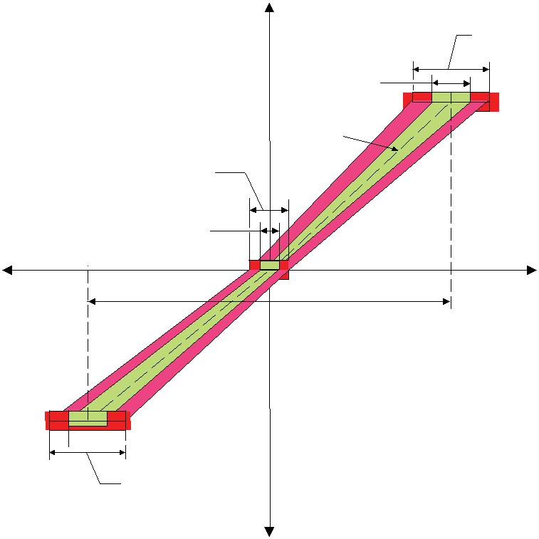

**Increasing VIOUT(V)**

Accuracy

Over Temp erature

Accuracy

25°C Only

Average

V**IOUT**

Accuracy

Over Temp erature

Accuracy

25°C Only

**IP(min)**

**–IP (A)** **+IP (A)**

put from its ideal quiescent value of VCC / 2 due to nonmagnetic causes. To convert this voltage to amperes, divide by the device sensitivity, Sens.

**Accuracy (ETOT).** The accuracy represents the maximum devia-tion of the actual output from its ideal value. This is also known as the total output error. The accuracy is illustrated graphically in the output voltage versus current chart at right.

Full Scale

**0 A**

 Accuracy

25°C Only

Accuracy

Over Temp erature

**Decreasing VIOUT(V)**

**IP(max)**

|  |  |  |
| --- | --- | --- |
| **ACS712** | ***Fully Integrated, Hall Effect-Based Linear Current Sensor IC*** |  |
| ***with 2.1 kVRMS Isolation and a Low-Resistance Current Conductor*** |  |
|  |  |  |

**Definitions of Dynamic Response Characteristics**

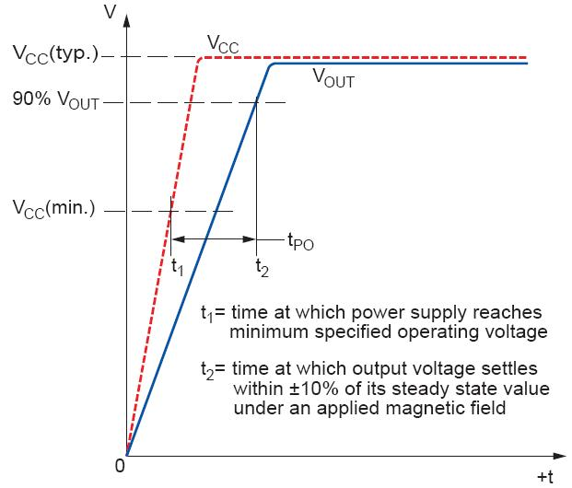

**Power-On Time (tPO).** When the supply is ramped to its operat-ing voltage, the device requires a finite time to power its internal components before responding to an input magnetic field.

Power-On Time, tPO , is defined as the time it takes for the output voltage to settle within ±10% of its steady state value under an applied magnetic field, after the power supply has reached its minimum specified operating voltage, VCC(min), as shown in the chart at right.

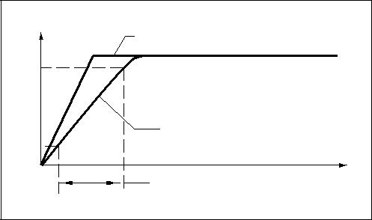

**Rise time (tr).** The time interval between a) when the devicereaches 10% of its full scale value, and b) when it reaches 90% of its full scale value. The rise time to a step response is used to derive the bandwidth of the device, in which ƒ(–3 dB) = 0.35 / tr.

Both tr and tRESPONSE are detrimentally affected by eddy current losses observed in the conductive IC ground plane.

|  |  |  |
| --- | --- | --- |
| R |  |  |
| T |  |

|  |  |  |
| --- | --- | --- |
| **ACS712** | ***Fully Integrated, Hall Effect-Based Linear Current Sensor IC*** |  |
| ***with 2.1 kVRMS Isolation and a Low-Resistance Current Conductor*** |  |
|  |  |  |

**Chopper Stabilization Technique**

Chopper Stabilization is an innovative circuit technique that is used to minimize the offset voltage of a Hall element and an asso-ciated on-chip amplifier. Allegro patented a Chopper Stabiliza-tion technique that nearly eliminates Hall IC output drift induced by temperature or package stress effects. This offset reduction technique is based on a signal modulation-demodulation process. Modulation is used to separate the undesired DC offset signal from the magnetically induced signal in the frequency domain. Then, using a low-pass filter, the modulated DC offset is sup-pressed while the magnetically induced signal passes through

the filter. As a result of this chopper stabilization approach, the output voltage from the Hall IC is desensitized to the effects of temperature and mechanical stress. This technique produces devices that have an extremely stable Electrical Offset Voltage, are immune to thermal stress, and have precise recoverability after temperature cycling.

This technique is made possible through the use of a BiCMOS process that allows the use of low-offset and low-noise amplifiers in combination with high-density logic integration and sample and hold circuits.

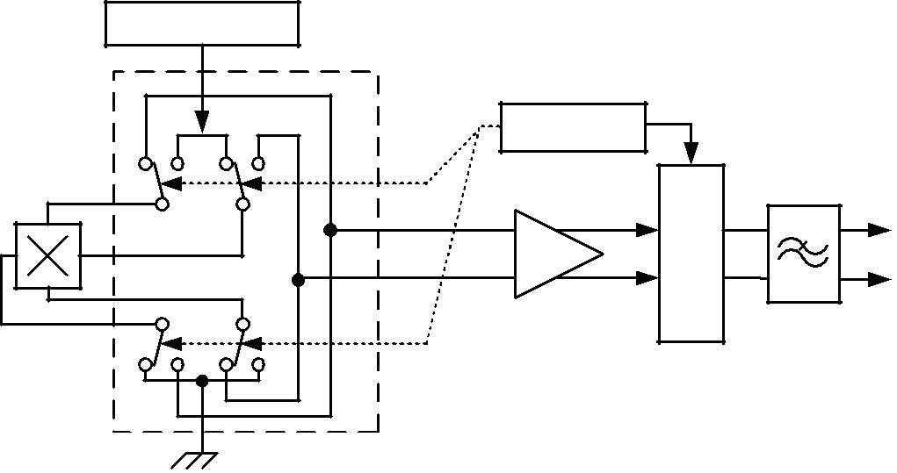

Regulator

Clock/Logic

Hall Element

Amp

|  |  |
| --- | --- |
| Hold | |
| Sample and | |

Low-Pass

Filter

Concept of Chopper Stabilization Technique

|  |  |  |
| --- | --- | --- |
| **ACS712** | ***Fully Integrated, Hall Effect-Based Linear Current Sensor IC*** |  |
| ***with 2.1 kVRMS Isolation and a Low-Resistance Current Conductor*** |  |
|  |  |  |

**Typical Applications**

|  |  |  |  |  |  |  |  |  |  |
| --- | --- | --- | --- | --- | --- | --- | --- | --- | --- |
|  |  | +5 V |  |  |  |  |  | VPEAK |  |
|  |  |  |  |  |  |  |  |  |
| CBYP | |  |  |  |  | C2 |  |  |  |
| 0.1 μF | |  |  |  |  | 0.1 μF | | VRESET |  |
|  |  |  |  |  |  | R4 | | Q1 |  |
|  |  | 8 |  | COUT |  | 10 kΩ | | 2N7002 |  |
| 1 |  |  |  |  |  |  |  |
| IP+ | VCC |  | 0.1 μF |  |  |  |  |  |
| 2 | IP+ | VIOUT 7 | RF | VOUT | + |  |  |  |  |
| IP | ACS712 | |  | – |  |  |  |  |
| 10 kΩ | R1 | U1 | D1 |  |  |
| 3 | IP– | FILTER 6 |  | 1 MΩ |  | LT1178 | 1N914 |  |  |
| 4 |  |  |  | CF |  |  |  |  |  |
| IP– | GND 5 |  | 1 nF |  |  |  |  |  |
|  |  |  |  | R3 | C1 |  |  |
|  |  |  |  | R2 |  |  |  |
|  |  |  |  | 33 kΩ |  | 330 kΩ | 0.1 μF |  |  |

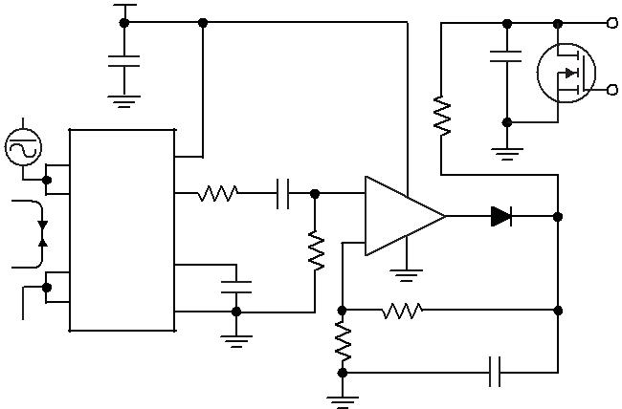

Application 2. Peak Detecting Circuit

+5 V

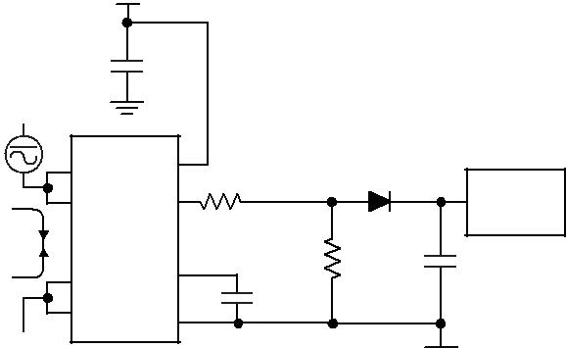

CBYP

|  |  |  |  |  |  |  |
| --- | --- | --- | --- | --- | --- | --- |
| 0.1 μF | |  |  |  |  |  |
| 1 |  | 8 |  |  | D1 |  |
| IP+ | VCC |  |  |  |
| 2 | VIOUT 7 | VOUT | | 1N4448W |  |
| IP+ | A-to-D |  |
|  |  |  | RF |  | Converter |  |
| IP | ACS712 | |  |  |  |
| 2 kΩ | R1 | C1 |  |
| 3 | IP– | FILTER 6 |  | 10 kΩ |  |
| 4 |  |  |  | CF |  |  |
| IP– | GND 5 |  | 1 nF |  |  |
|  |  |  |  |  |

Application 4. Rectified Output. 3.3 V scaling and rectification application for A-to-D converters. Replaces current transformer solutions with simpler ACS circuit. C1 is a function of the load resistance and filtering desired.

R1 can be omitted if the full range is desired.

|  |  |  |  |  |  |  |  |
| --- | --- | --- | --- | --- | --- | --- | --- |
|  |  | +5 V |  |  |  |  |  |
| CBYP | |  | R1 |  |  |  |  |
| 0.1 μF | |  | 100 kΩ |  |  |  |  |
|  |  |  |  |  |  |  |
|  |  |  | R2 |  |  |  |  |
|  |  | 8 | 100 kΩ | 1 | LM321 |  |  |
| 1 |  |  | + | 5 | VOUT |  |
| IP+ | VCC |  | 4 |  |
| 2 | VIOUT 7 |  | 3 – |  |  |  |
| IP+ | RF | 2 |  |  |
| IP | ACS712 | |  |  | C1 |  |
| 1 kΩ |  | R3 |  |
| 3 |  | FILTER 6 |  |  | 1000 pF |  |
| IP– | CF |  | 3.3 kΩ |  |  |
| 4 | IP– | 5 | 0.01 μF |  |  |  |  |
|  |  | GND |  |  |  |  |  |

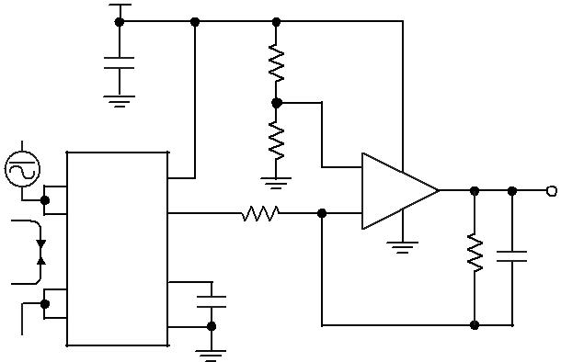

Application 3. This configuration increases gain to 610 mV/A

(tested using the ACS712ELC-05A).

|  |  |  |  |  |  |  |  |  |  |
| --- | --- | --- | --- | --- | --- | --- | --- | --- | --- |
|  |  | +5 V |  |  |  |  |  |  |  |
| CBYP | |  | R1 |  |  |  |  |  |  |
| 0.1 μF | |  | 33 kΩ |  |  |  |  |  |  |
|  |  |  |  |  |  |  |  |  |
|  |  |  | R2 |  |  |  |  | RPU |  |
|  |  |  |  |  |  |  | 100 kΩ |  |
|  |  | 8 | 100 kΩ |  |  |  |  |  |  |
| 1 |  |  |  |  |  |  |  |  |
| IP+ | VCC | VOUT |  |  |  |  |  |  |
| 2 | VIOUT 7 | 4 |  | 5 |  |  |  |
| IP+ | – | 1 | Fault |  |
| IP | ACS712 | |  | 3 | + | 2 | U1 |  |  |
| 3 |  | FILTER 6 |  |  |  |  |
| IP– | CF |  |  |  | LMV7235 | |  |
| 4 | IP– | 5 | 1 nF |  |  |  |  |  |  |
|  |  | GND |  |  |  |  |  |  |  |
|  |  |  |  |  |  | D1 | |  |  |
|  |  |  |  |  |  | 1N914 | |  |  |

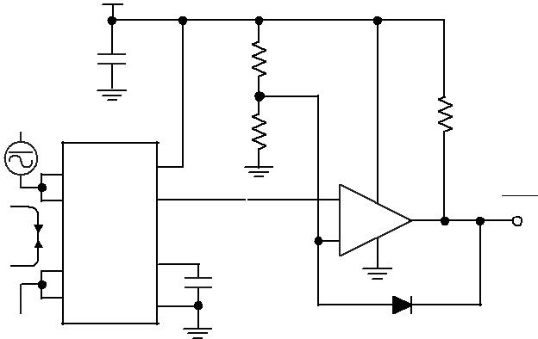

Application 5. 10 A Overcurrent Fault Latch. Fault threshold set by R1 and R2. This circuit latches an overcurrent fault and holds it until the 5 V rail is powered down

|  |  |  |
| --- | --- | --- |
| **ACS712** | ***Fully Integrated, Hall Effect-Based Linear Current Sensor IC*** |  |
| ***with 2.1 kVRMS Isolation and a Low-Resistance Current Conductor*** |  |
|  |  |  |

**Improving Sensing System Accuracy Using the FILTER Pin**

In low-frequency sensing applications, it is often advantageous to add a simple RC filter to the output of the device. Such a low-pass filter improves the signal-to-noise ratio, and therefore the resolution, of the device output signal. However, the addition of an RC filter to the output of a sensor IC can result in undesirable device output attenuation — even for DC signals.

Signal attenuation, ∆VATT , is a result of the resistive divider effect between the resistance of the external filter, RF (see Application 6), and the input impedance and resistance of the customer interface circuit, RINTFC. The transfer function of this resistive divider is given by:

|  |  |  |  |  |  |  |  |  |
| --- | --- | --- | --- | --- | --- | --- | --- | --- |
|  |  |  | | *R*INTFC | |  | . |  |
| *∆V* | *V* |  |  |  |  |  |  |
|  |  | + *R* |  |
| ATT = | IOUT *R* | | |  |  |  |
|  |  |  | | F | INTFC | |  |  |

Even if RF and RINTFC are designed to match, the two individual resistance values will most likely drift by different amounts over

+5 V

temperature. Therefore, signal attenuation will vary as a function of temperature. Note that, in many cases, the input impedance,

RINTFC , of a typical analog-to-digital converter (ADC) can be as low as 10 kΩ.

The ACS712 contains an internal resistor, a FILTER pin connec-tion to the printed circuit board, and an internal buffer amplifier. With this circuit architecture, users can implement a simple

RC filter via the addition of a capacitor, CF (see Application 7) from the FILTER pin to ground. The buffer amplifier inside of the ACS712 (located after the internal resistor and FILTER pin connection) eliminates the attenuation caused by the resistive divider effect described in the equation for ∆VATT. Therefore, the ACS712 device is ideal for use in high-accuracy applications that cannot afford the signal attenuation associated with the use of an external RC low-pass filter.

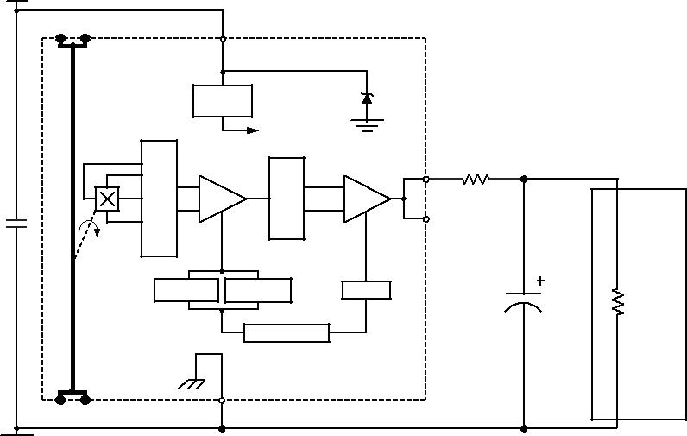

|  |  |  |  |  |  |  |  |  |  |  |  |  |  |
| --- | --- | --- | --- | --- | --- | --- | --- | --- | --- | --- | --- | --- | --- |
|  |  | Pin 3 | | Pin 4 |  |  | VCC |  |  |  |  |  |  |
|  |  | IP– | | IP– |  |  | Pin 8 |  |  |  |  |  |  |
|  |  |  |  |  |  |  |  |  |  |  |  |  |
| Application 6. When a low pass filter is constructed |  |  |  |  |  |  | Allegro ACS706 | |  |  |  |  |  |
|  |  |  |  |  |  |  |  |  |  |  |  |  |
| externally to a standard Hall effect device, a resistive | |  |  |  |  | Voltage | |  |  |  |  |  |  |
|  |  |  |  | Regulator | |  |  |  |  |  |  |
| divider may exist between the filter resistor, RF, and |  |  |  |  |  |  | To all subcircuits |  |  |  |  |  |  |
| the resistance of the customer interface circuit, RINTFC. | |  |  |  |  |  |  |  | VIOUT |  | Resistive Divider |  |  |
| This resistive divider will cause excessive attenuation, | |  |  |  |  |  |  |  |  |  |  |
|  |  | Dynamic Offset | Cancellation |  |  |  | Pin 7 |  | Input |  |  |
|  |  |  |  |  |  |  |  |  |
| as given by the transfer function for ∆V . |  |  |  | Amp | Filter | Out | N.C. | RF | Application |  |  |
| ATT |  | 0.1 F |  |  |  | Pin 6 |  | Interface |  |  |
|  |  |  |  |  |  |  |  | Circuit |  |  |
|  |  |  |  |  |  |  |  |  |  |  |
|  |  |  |  |  |  |  |  |  | Low Pass Filter | |  |  |  |
|  |  |  |  |  |  | Gain | Temperature | Offset |  | CF |  |  |  |
|  |  |  |  |  |  | Coefficient |  | RINTFC |  |  |
|  |  |  |  |  |  |  |  |  |  | 1 nF |  |  |
|  |  |  |  |  |  |  | Trim Control |  |  |  |  |  |  |
|  |  | IP+ |  | IP+ |  |  | GND |  |  |  |  |  |  |
|  |  | Pin 1 | | Pin 2 |  |  | Pin 5 |  |  |  |  |  |  |

|  |  |  |
| --- | --- | --- |
| **ACS712** | ***Fully Integrated, Hall Effect-Based Linear Current Sensor IC*** |  |
| ***with 2.1 kVRMS Isolation and a Low-Resistance Current Conductor*** |  |
|  |  |  |

**Package LC, 8-pin SOIC**

|  |  |  |  |  |  |  |  |
| --- | --- | --- | --- | --- | --- | --- | --- |
|  | 4.90 ±0.10 | 8° |  |  | 8 |  |  |
|  |  |  |  | 1.27 |  |
| 8 |  | 0° |  | 0.65 |  |
|  |  |  | 1.75 |  |  |  |
|  |  |  | 0.25 |  |  |  |
|  |  |  |  |  |  |  |
|  |  |  | 0.17 |  |  |  |  |

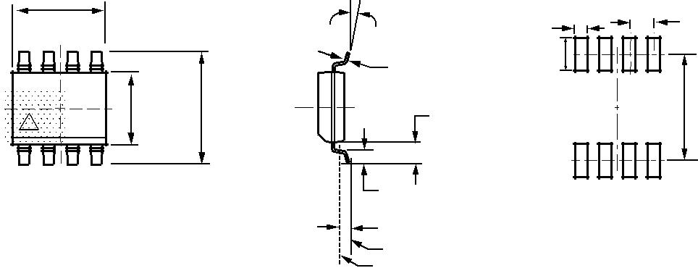

|  |  |  |  |  |
| --- | --- | --- | --- | --- |
| 3.90 ±0.10 | 6.00 ±0.20 | 1.04 REF | 5.60 |  |
| A |  |  |  |
|  |  |  |  |